



SETUP DOCUMENT

LARP EVENT SOFTWARE SOLUTION

Version 2.0

Dholon Akter | Nr. 3047040

Chanelle Hart | Nr. 3323781

Talia Santos | Nr. 3294579

Thanh Hoàng | Nr. 3353362

GROUP 34

# Version History

|  |  |  |  |  |  |
| --- | --- | --- | --- | --- | --- |
| **Version #** | **Implemented By** | **Revision Date** | **Approved By** | **Approval Date** | **Reason** |
| 0.5 | T. Santos | 6th Mar | - | - | Rough draft |
| 0.6 | C. Hart | 9th Mar | - | - |  |
| 1.0 | T. Hoàng | 11th Mar | - | - | Add GUIs, Wireframes, ERD |
| 2.0 | T. Hoàng | 18th Mar | - | - | Finalization |
| 3.0 | T. Santos | 24th Jun | - | - | Touch up, remove old GUI for replacement |

Table of Contents

Version History 2

Agreements 4

Processes 4

Functional Requirements 4

GUI 5

Wireframes 22

Visual Design 39

ERD 56

# Agreements

**Applications:**

* The applications should have functionalities supporting the management and personnel of the events.
* The applications will run on Windows.
* The applications should be user-friendly and accessible to all personnel and management.
* The applications for stores and loan stands should be self-service.

**Website:**

* The website should have functionalities supporting the purchase tickets and/or reservations of camping spots.
* The website should be visually appealing and informative to potential visitors.
* All personal information on the website will be carefully stored.
* The website will be able to run on mobile devices.

# Functional Requirements

|  |  |  |  |  |
| --- | --- | --- | --- | --- |
|  | **Must have** | **Should have** | **Could have** | **Won’t have** |
| **Website** | [WMH1] Website is informative  [WMH2] Website has visual appeal  [WMH3] User can purchase tickets  [WMH4] User can reserve camps  [WMH5] Website stores information safely | [WSH1] Website is responsive on mobile devices | [WCH1] Website can have an about page for the company  [WCH2] Website can have an about page for the events  [WCH3] Website can have room for feedback  [WCH4] Website can have links to social media  [WCH5] Website can have a picture gallery | [WWH1] Website will not process payments |
| **Applications** | [AMH1] Application can monitor visitors: enter, exit and quantity  [AMH2] Application supports selling and loaning items  [AMH3] User can have an overview of the event  [AMH4] Application can handle ATM logs  [AMH5]  Application can run on Windows | [ASH1] Application is user-friendly  [ASH2] Application have manuals | [ACH1] A mobile application for stores and loan stands |  |

# GUI

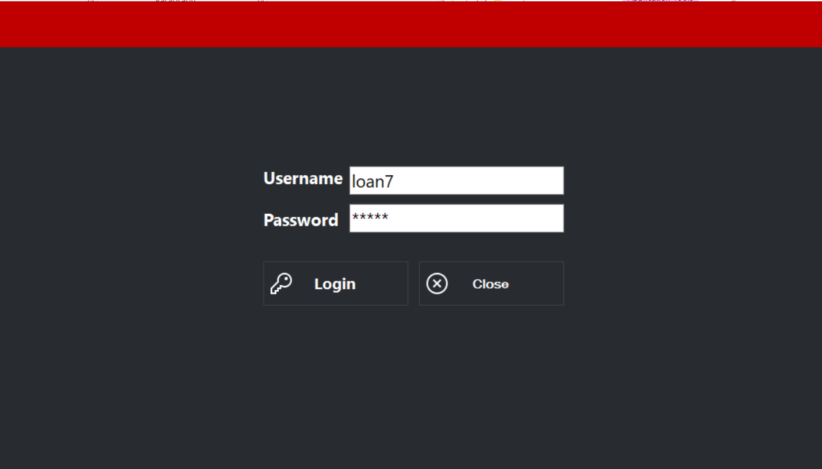

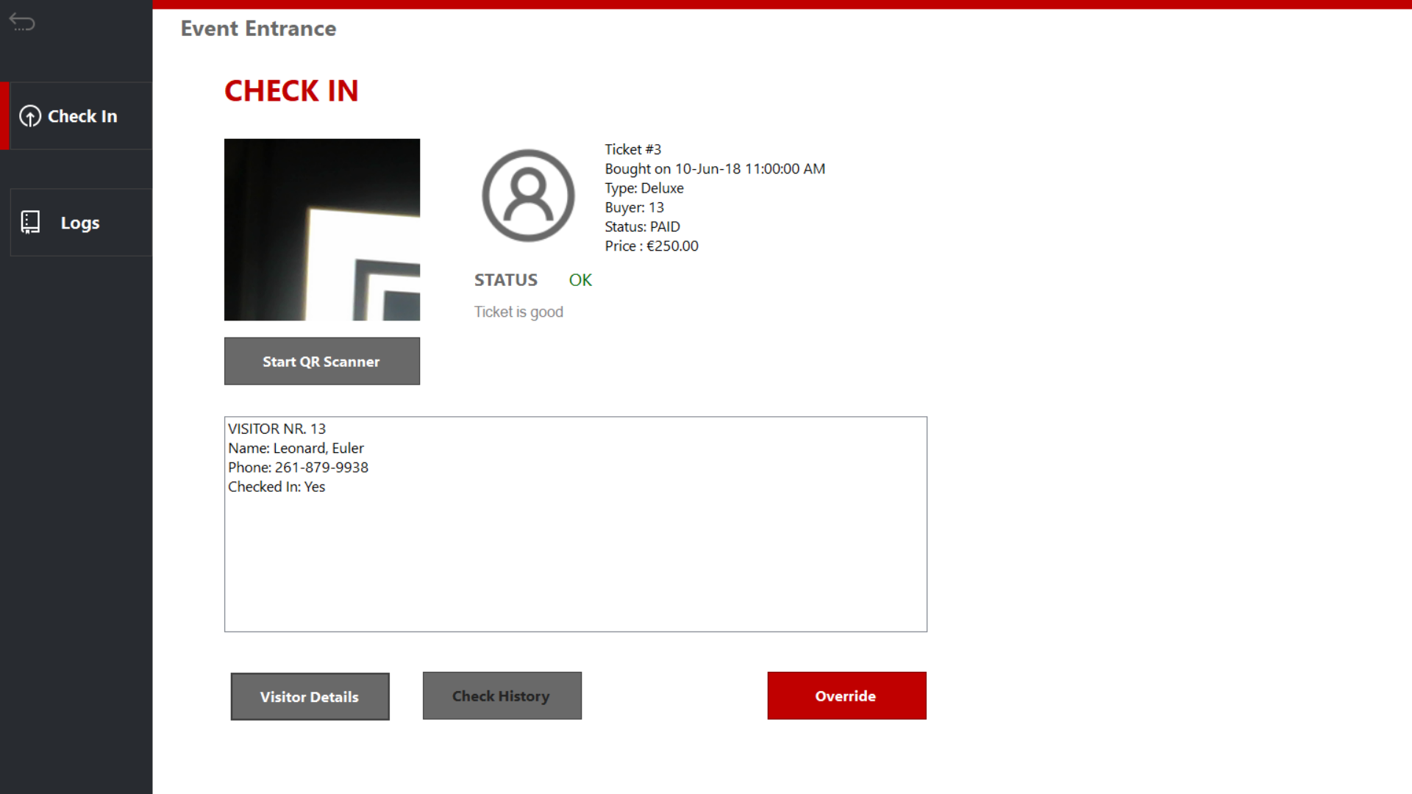

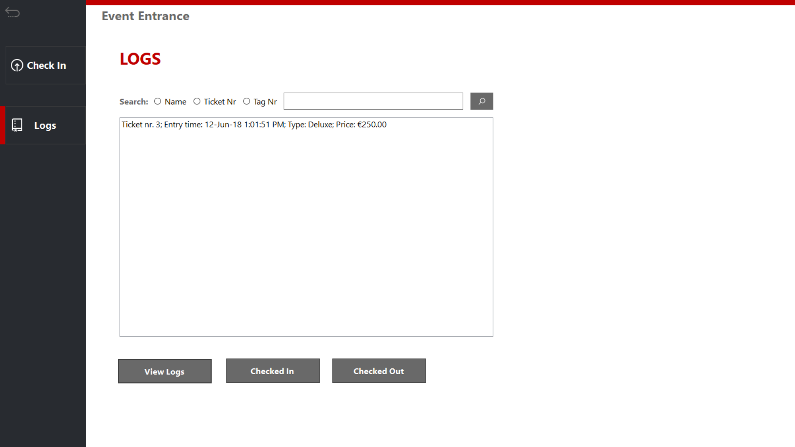

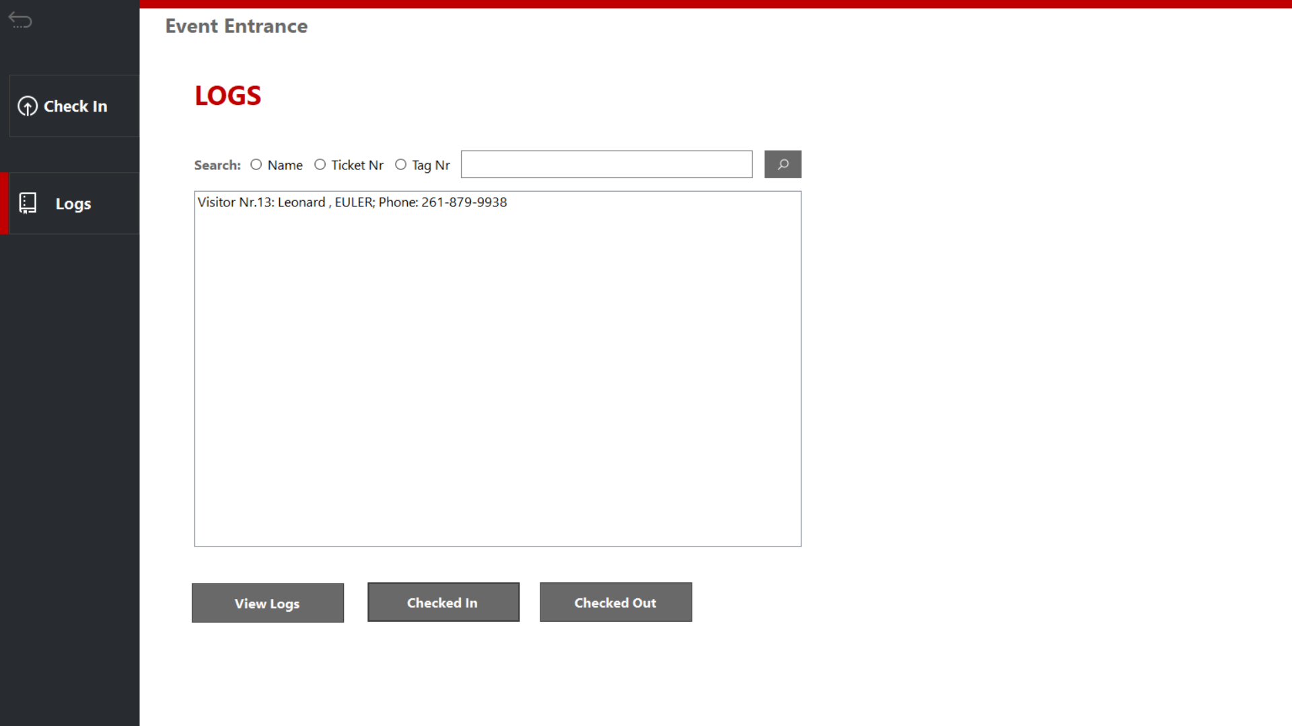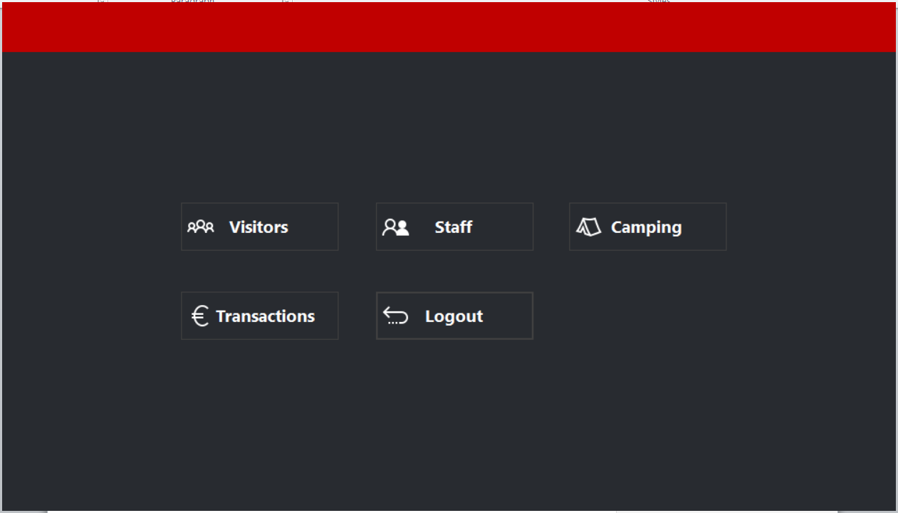 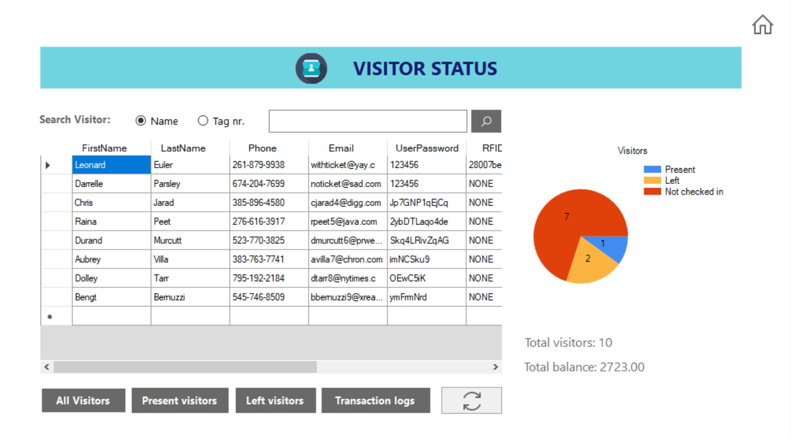

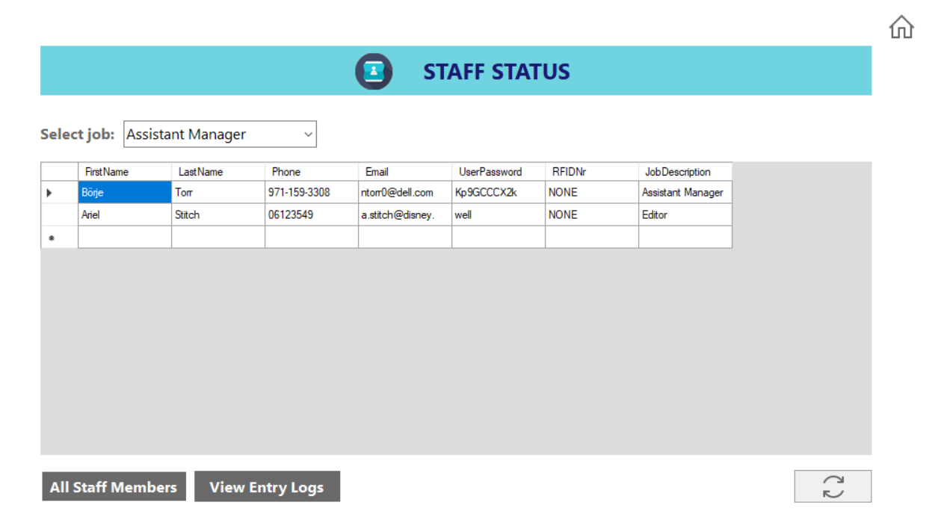

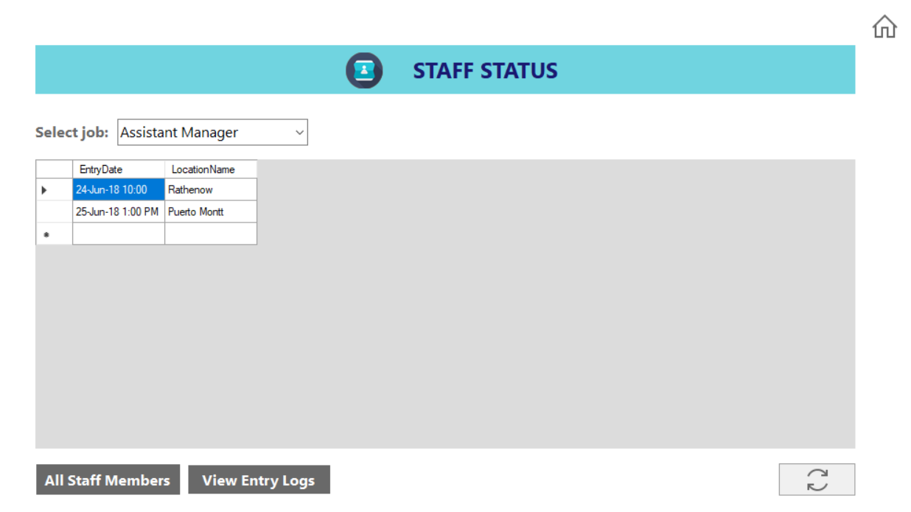

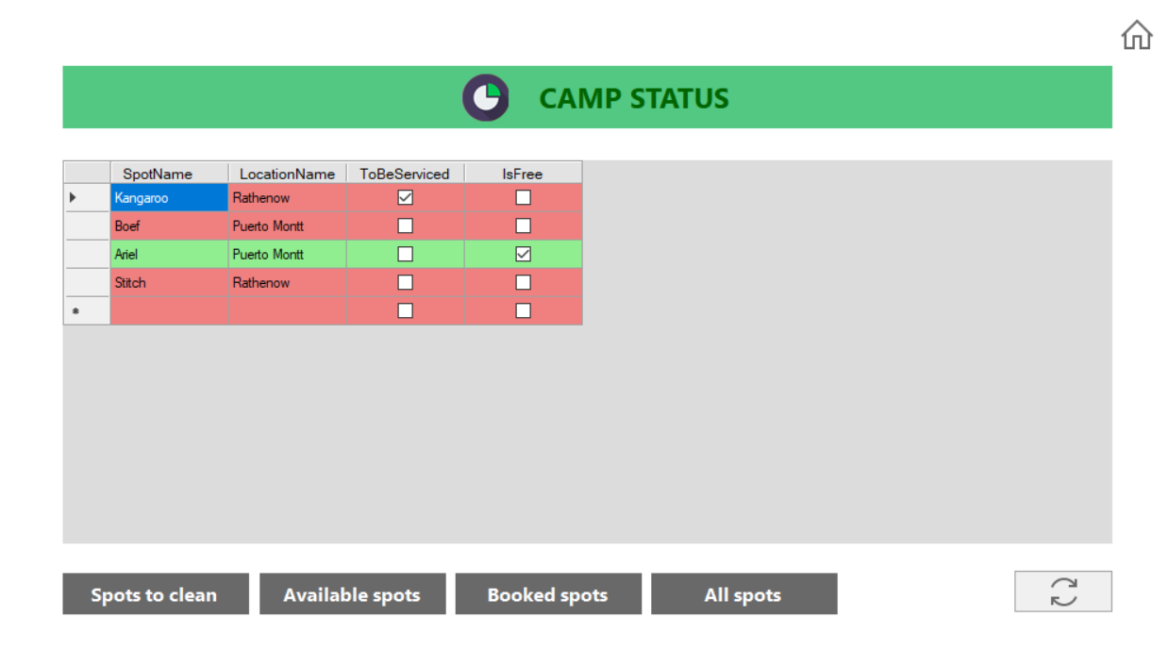

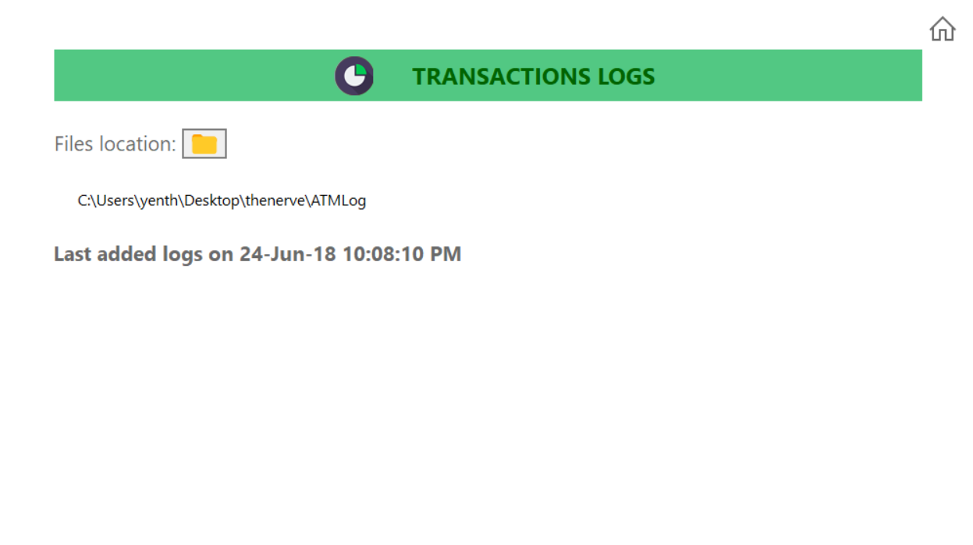

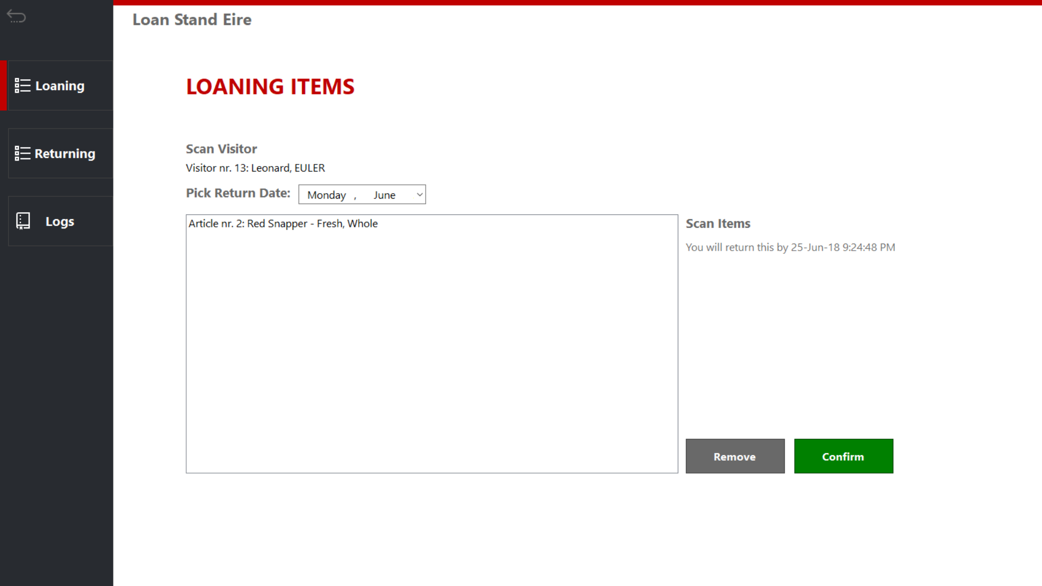 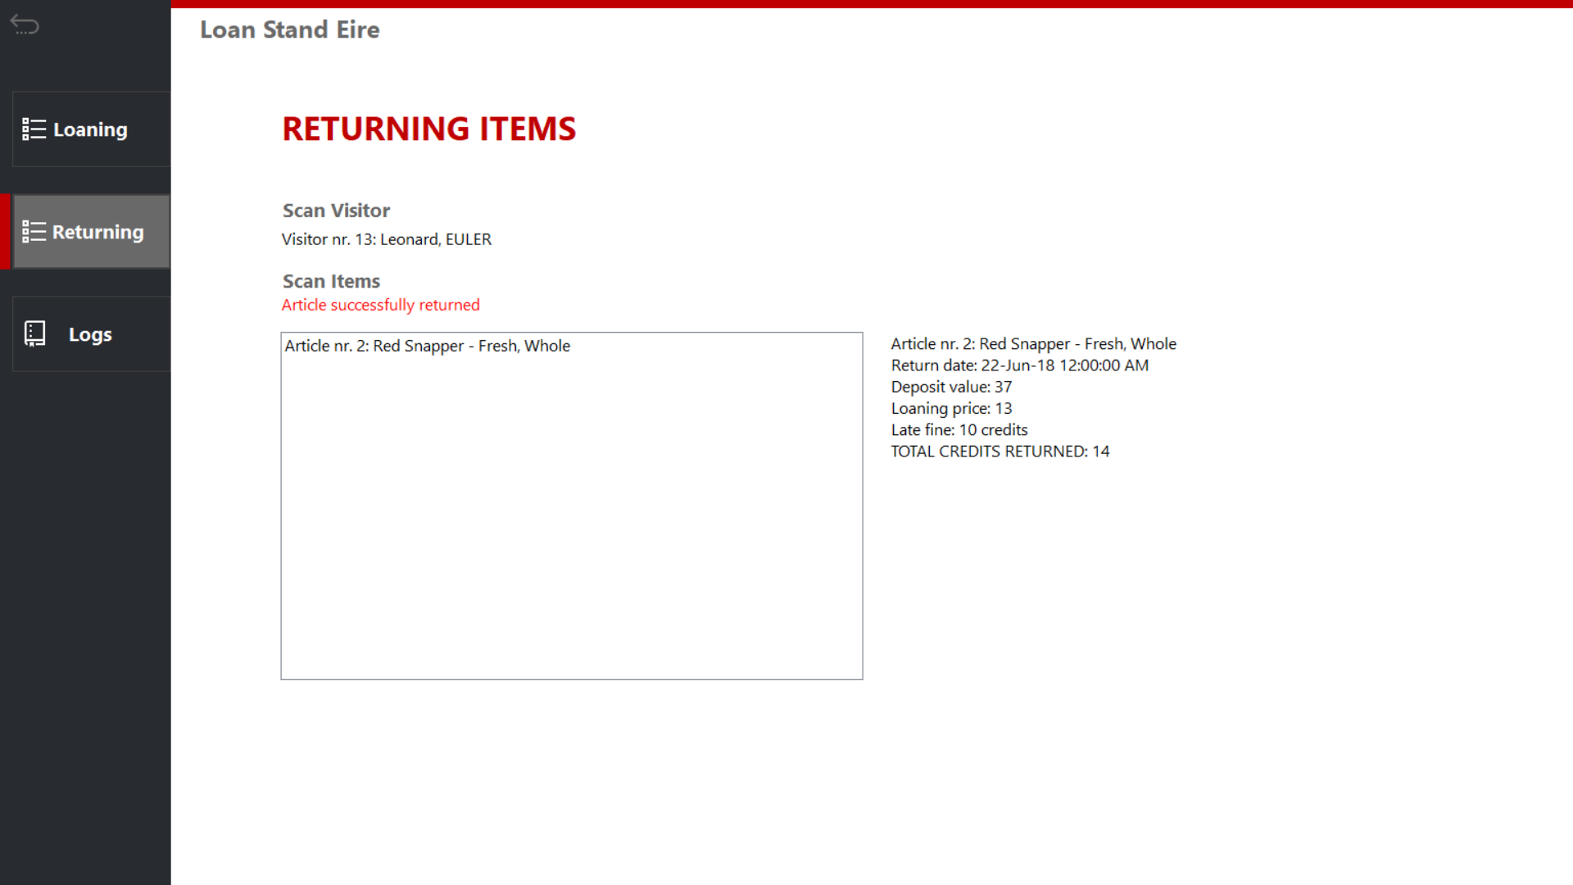

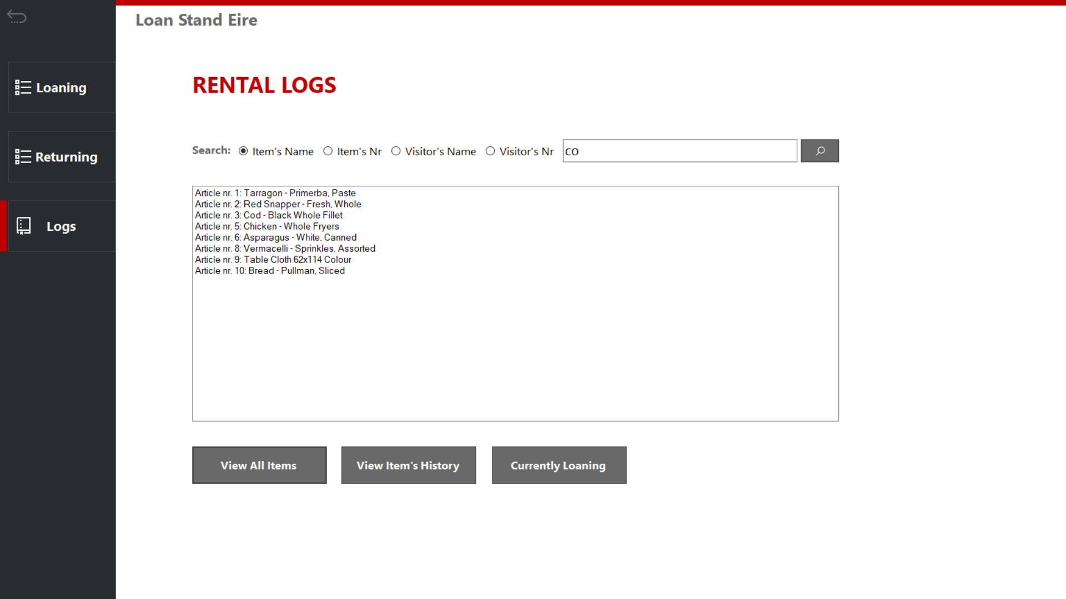

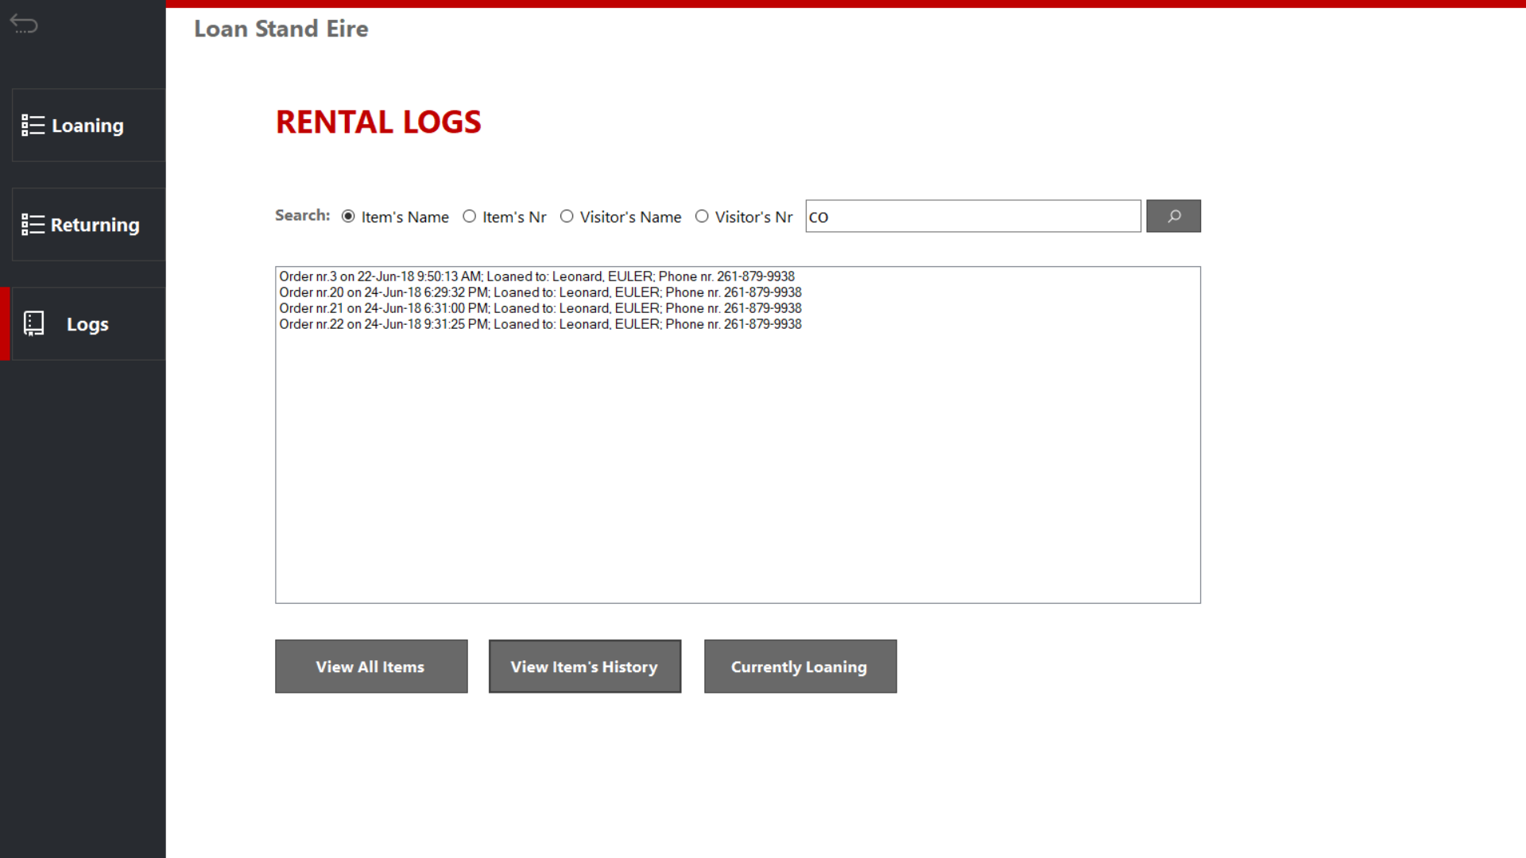

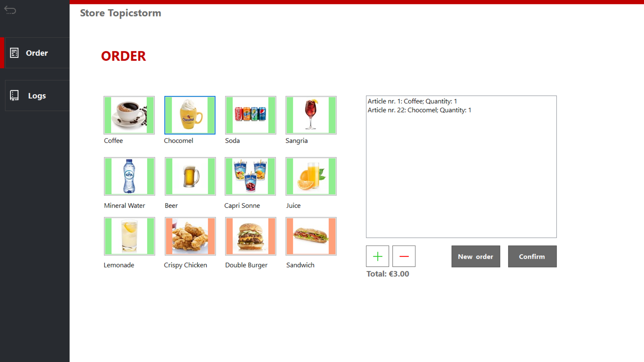

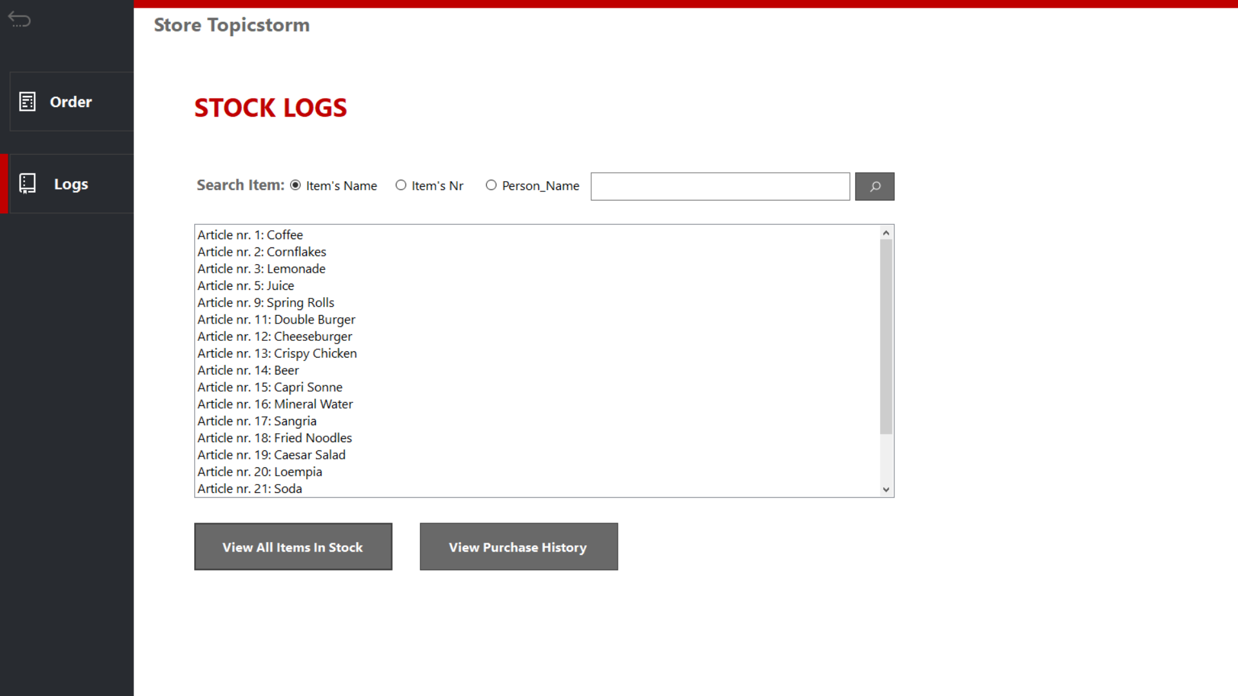

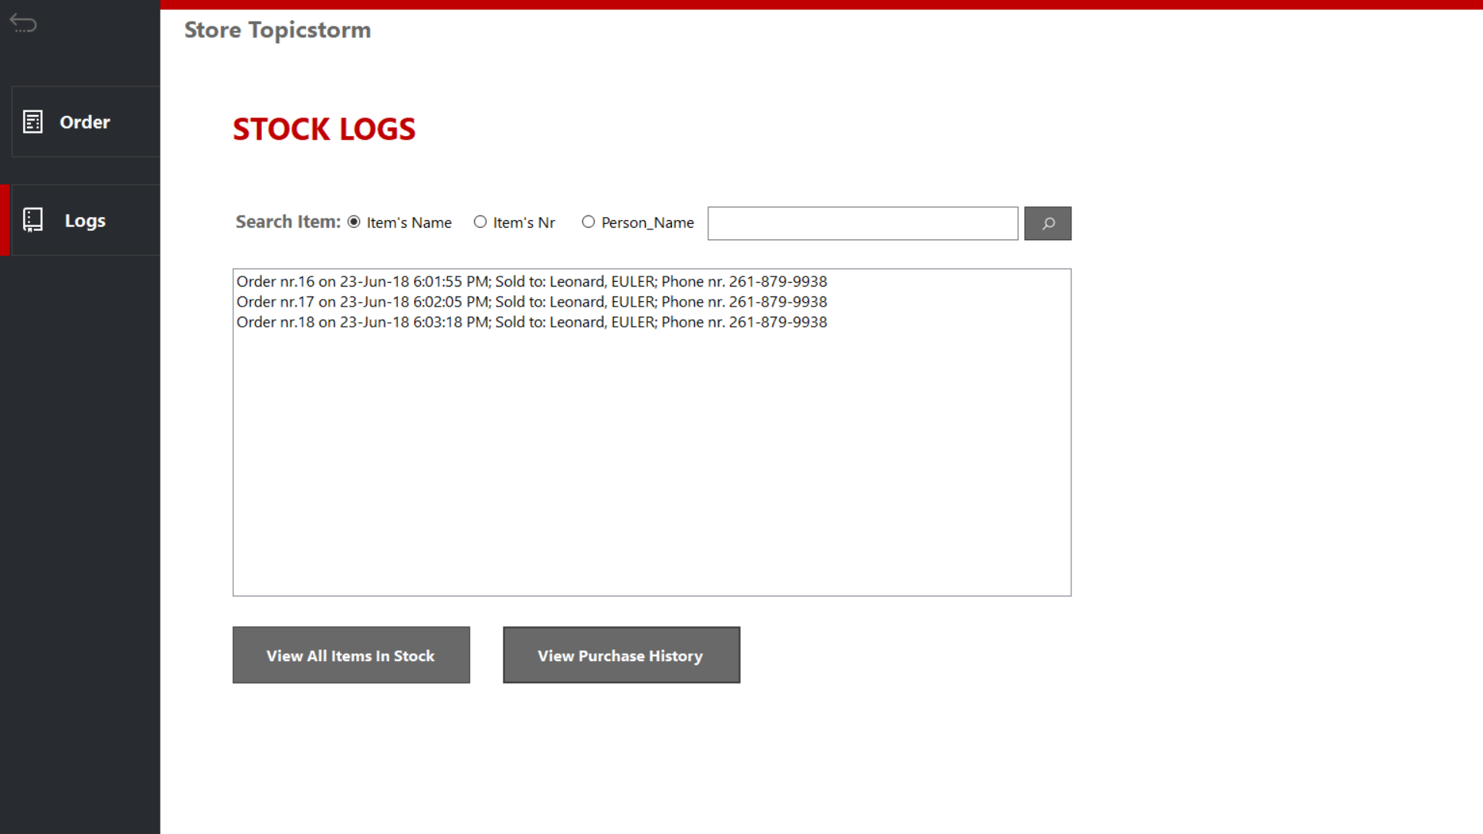

# Wireframes

**Homepage:**

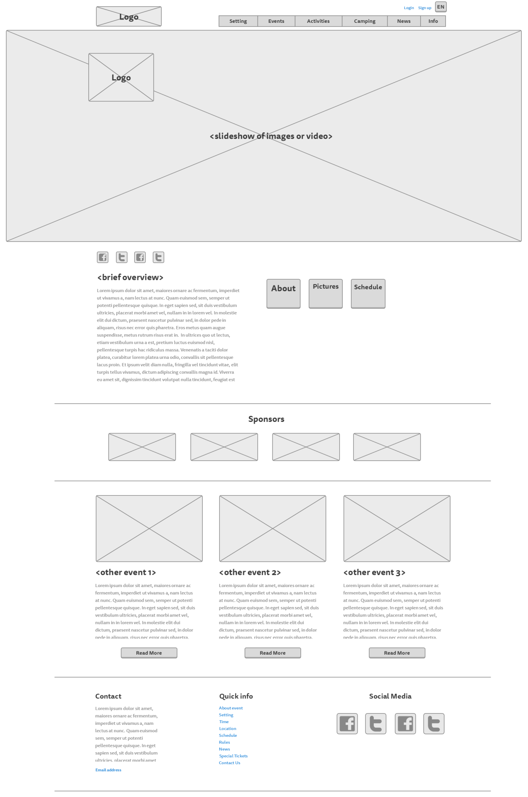

**Setting page:**

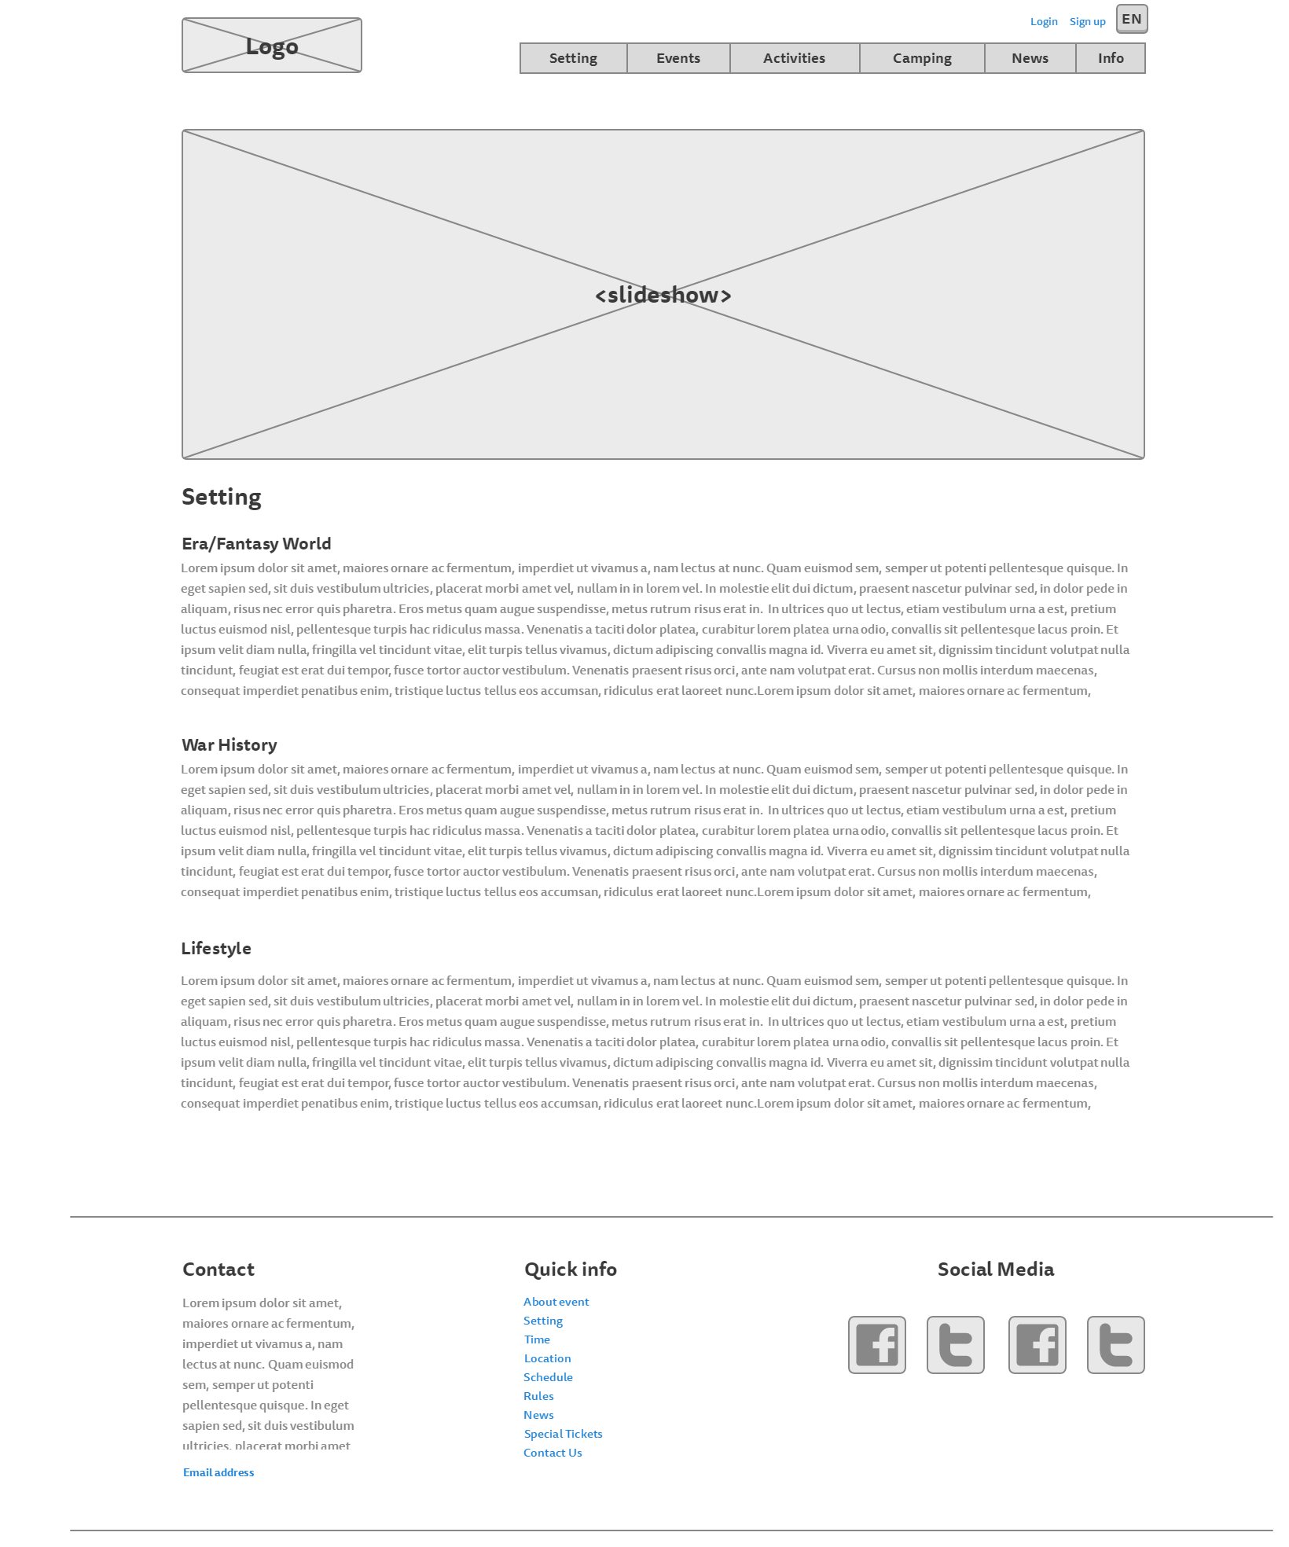

**Rules page:**

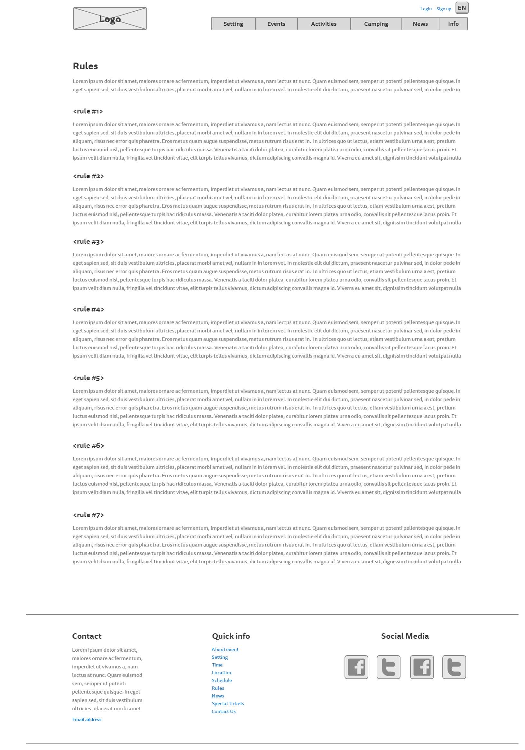

**Events page**

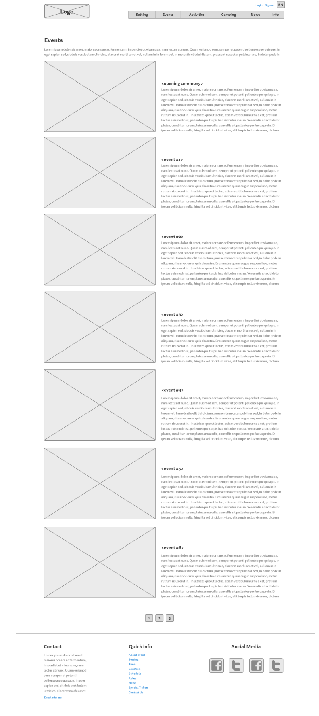

**Activities page:**

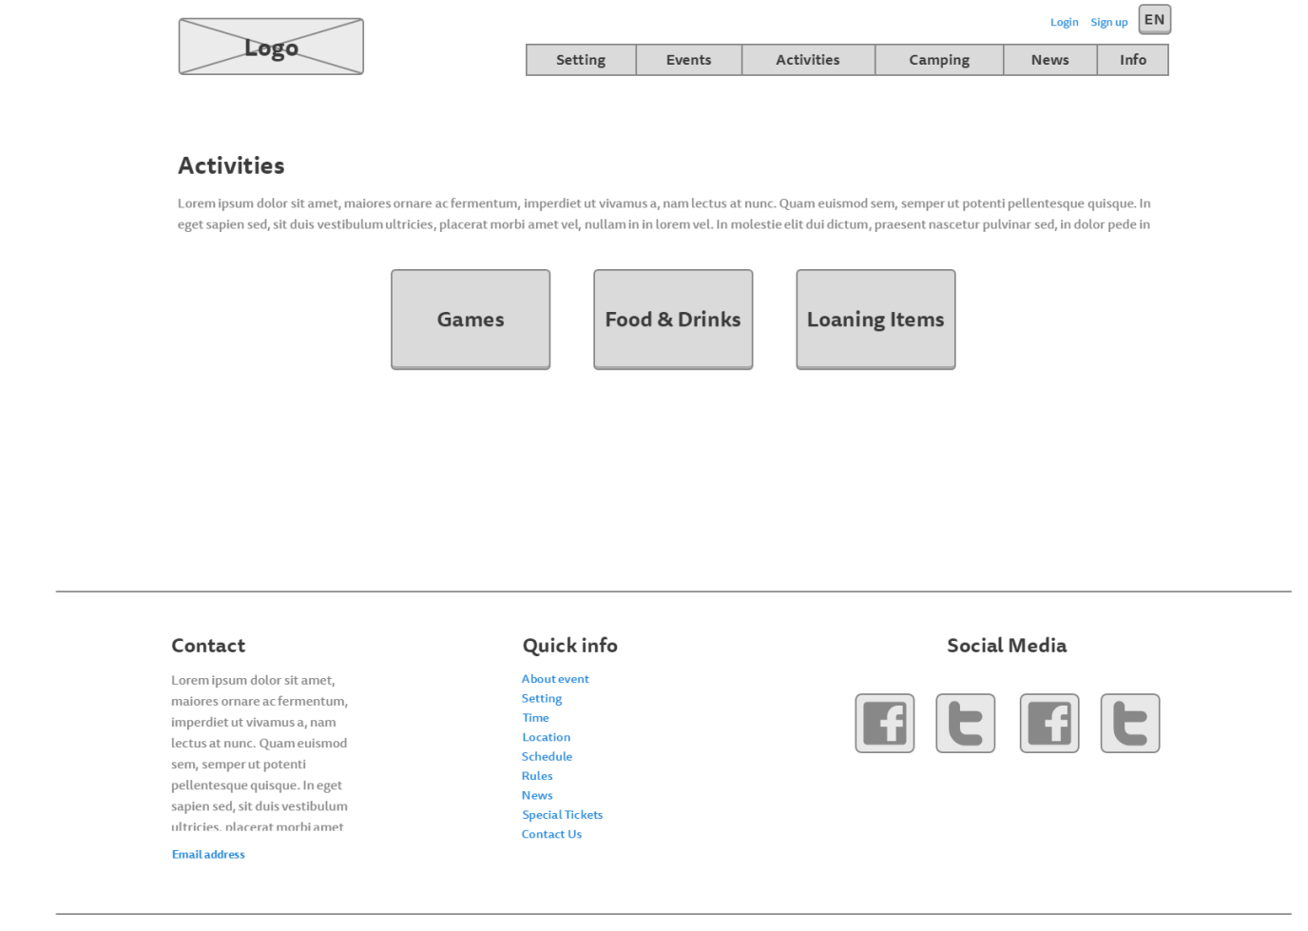

**Food, drinks and loaning items page**

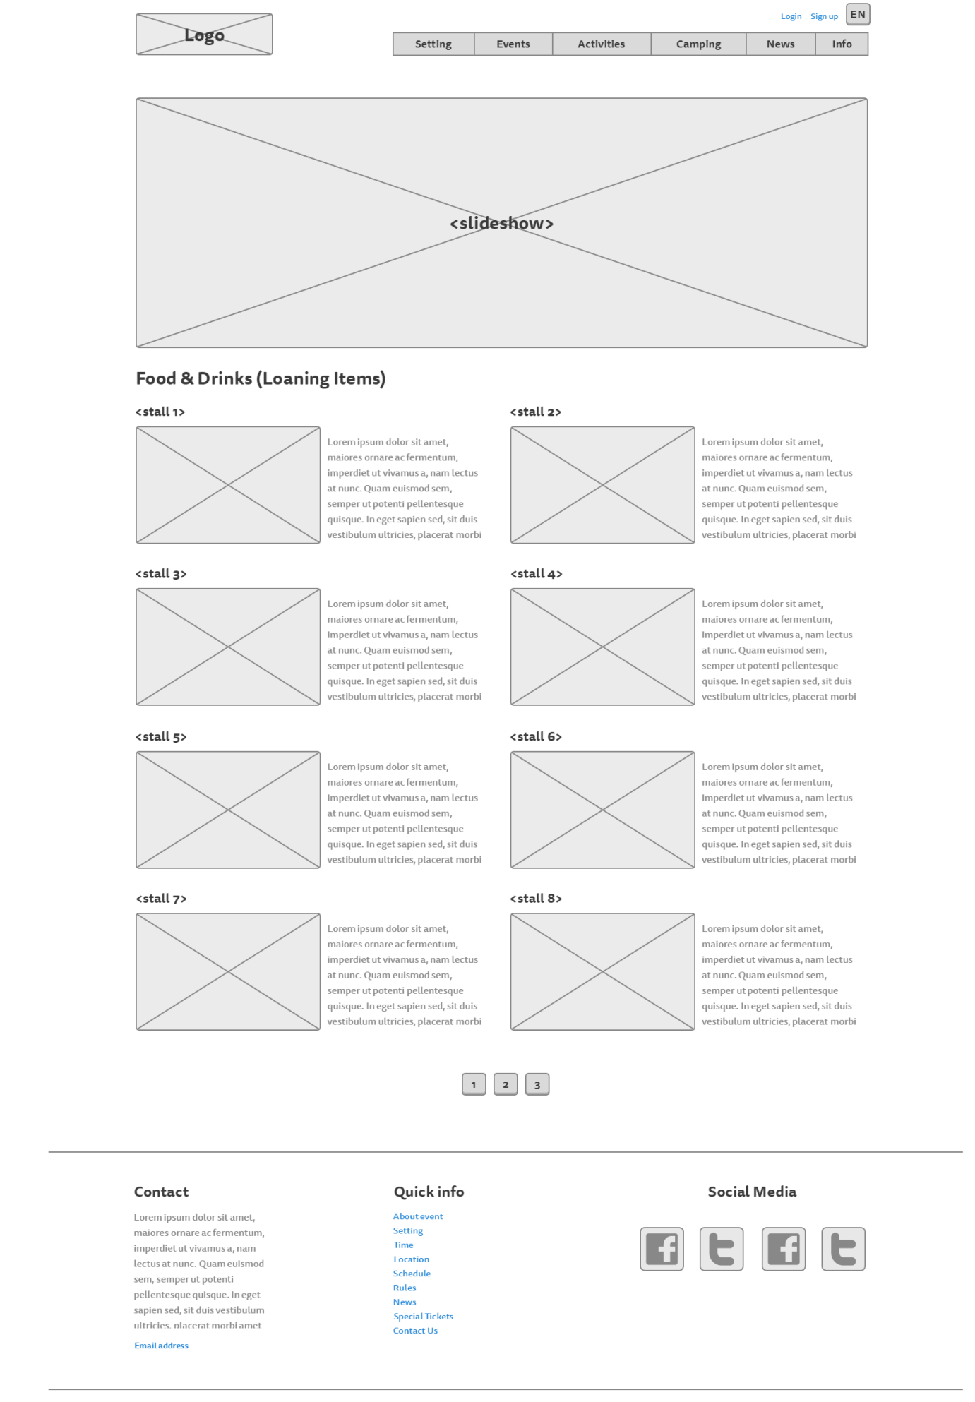

**Games page:**

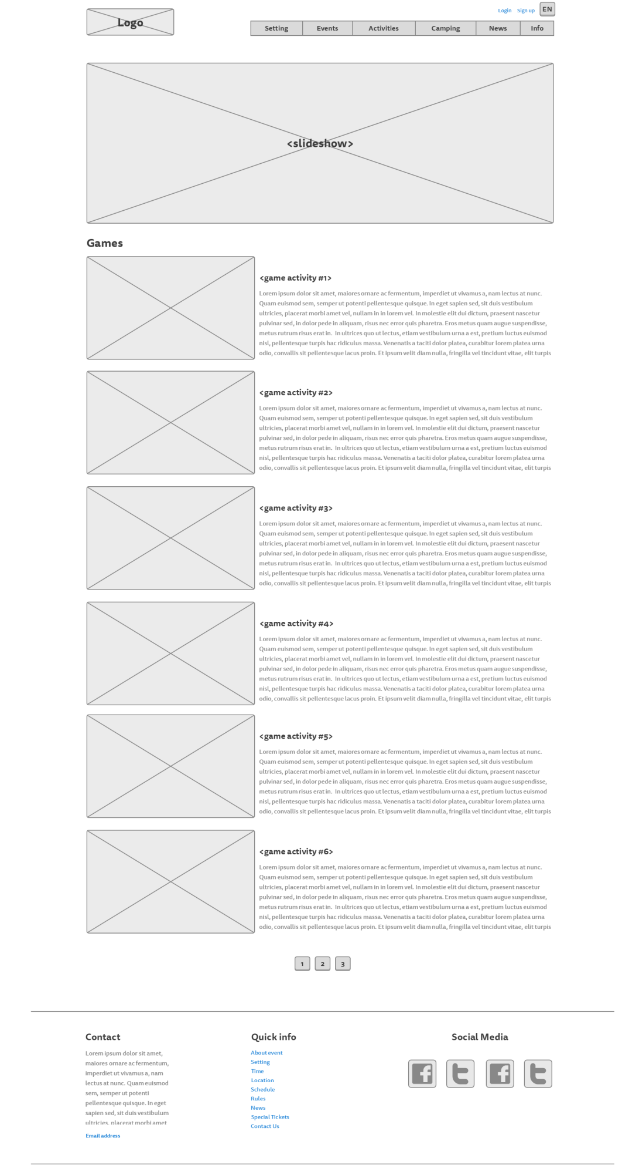

**Camping page:**

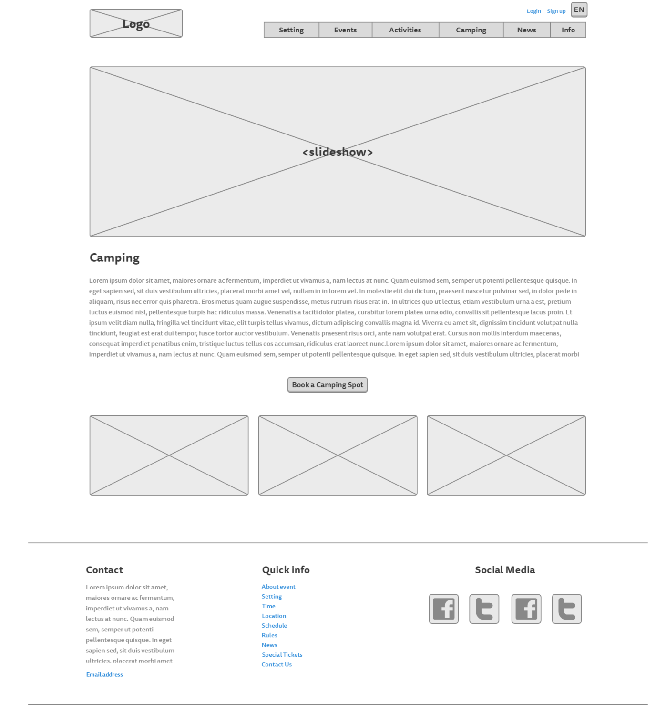

**News page:**

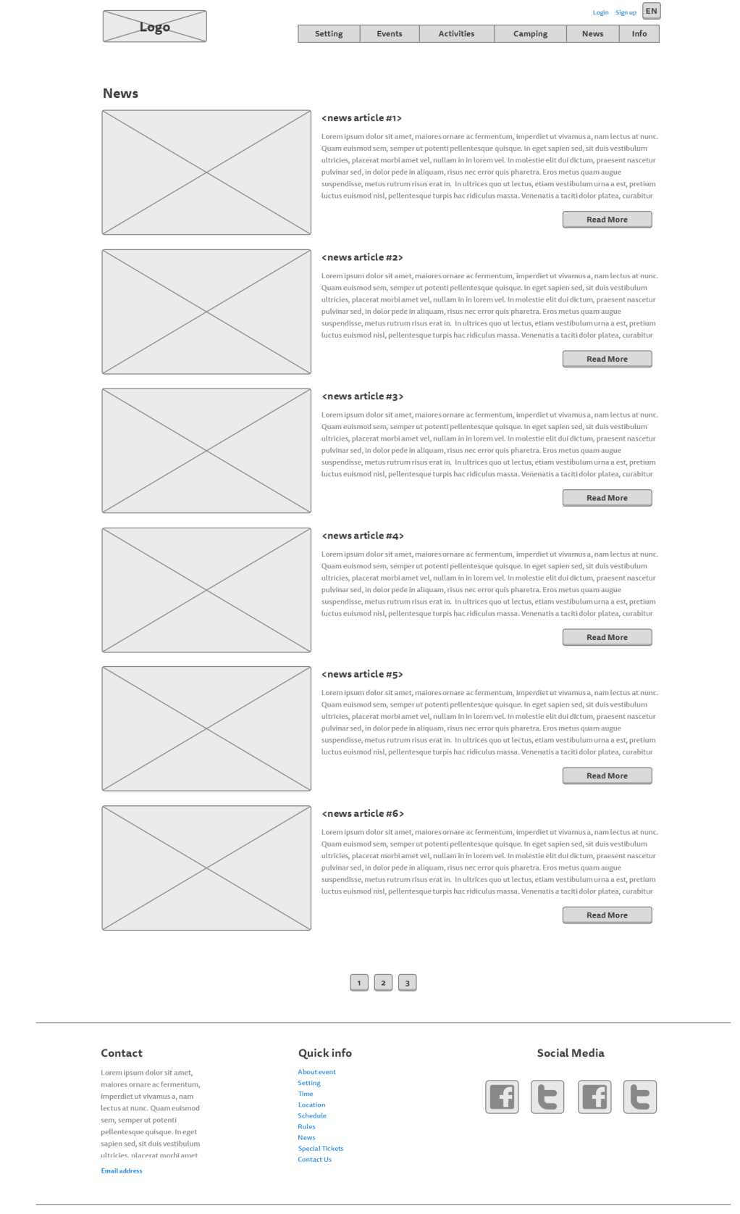

*News – read more:*

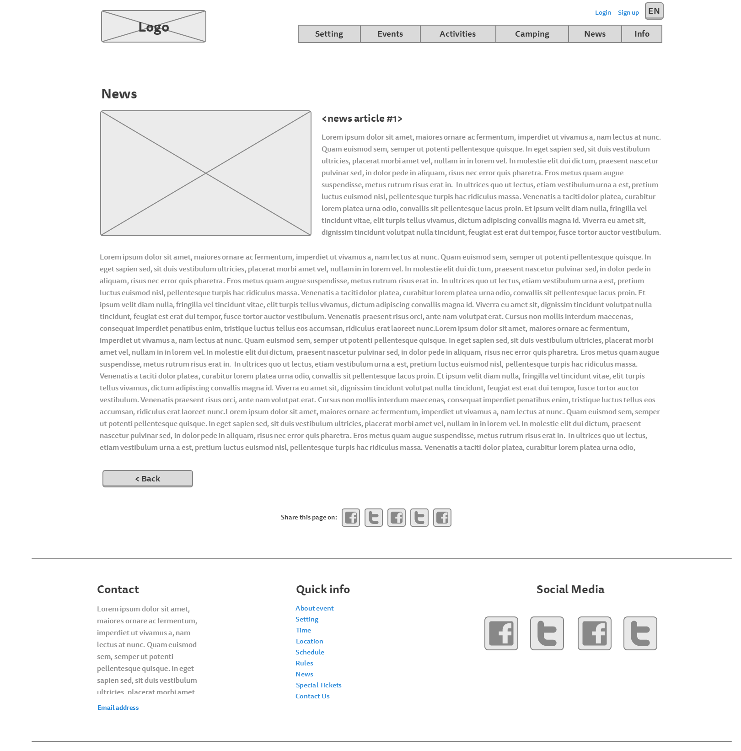

**About page:**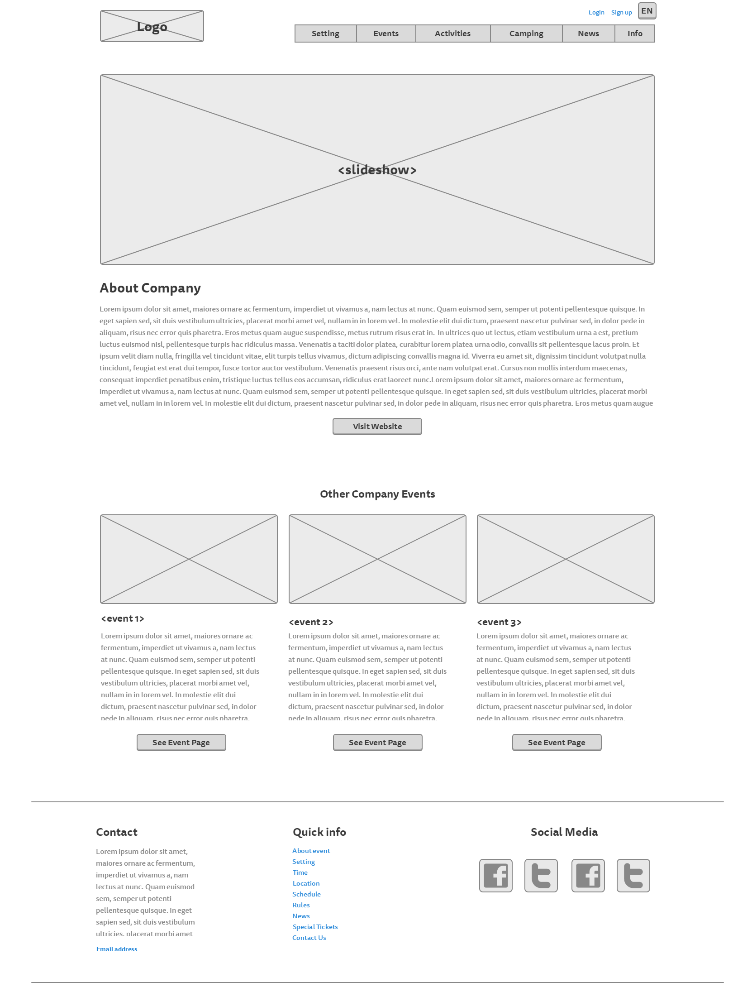

**Login page:**

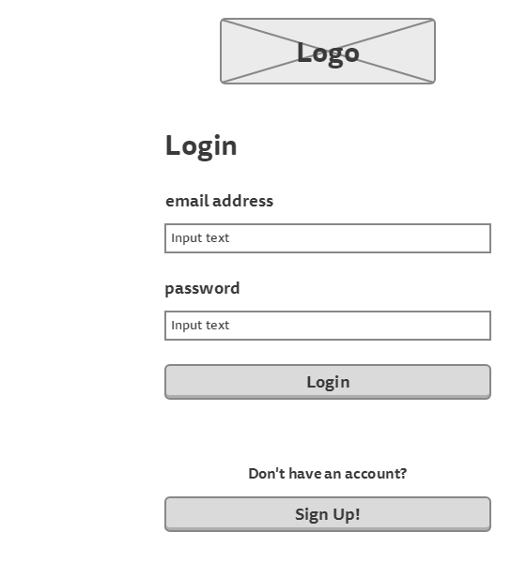

**Sign up page:**

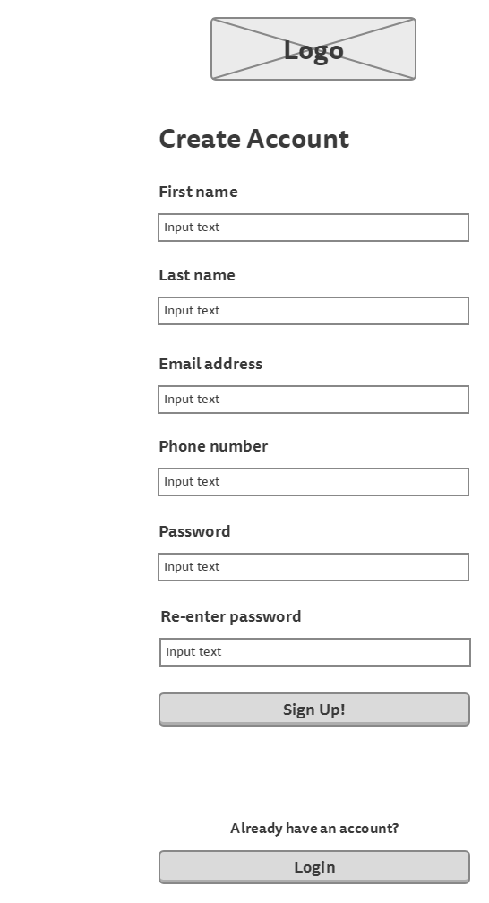

**Participant’s information page** (to show tickets information)

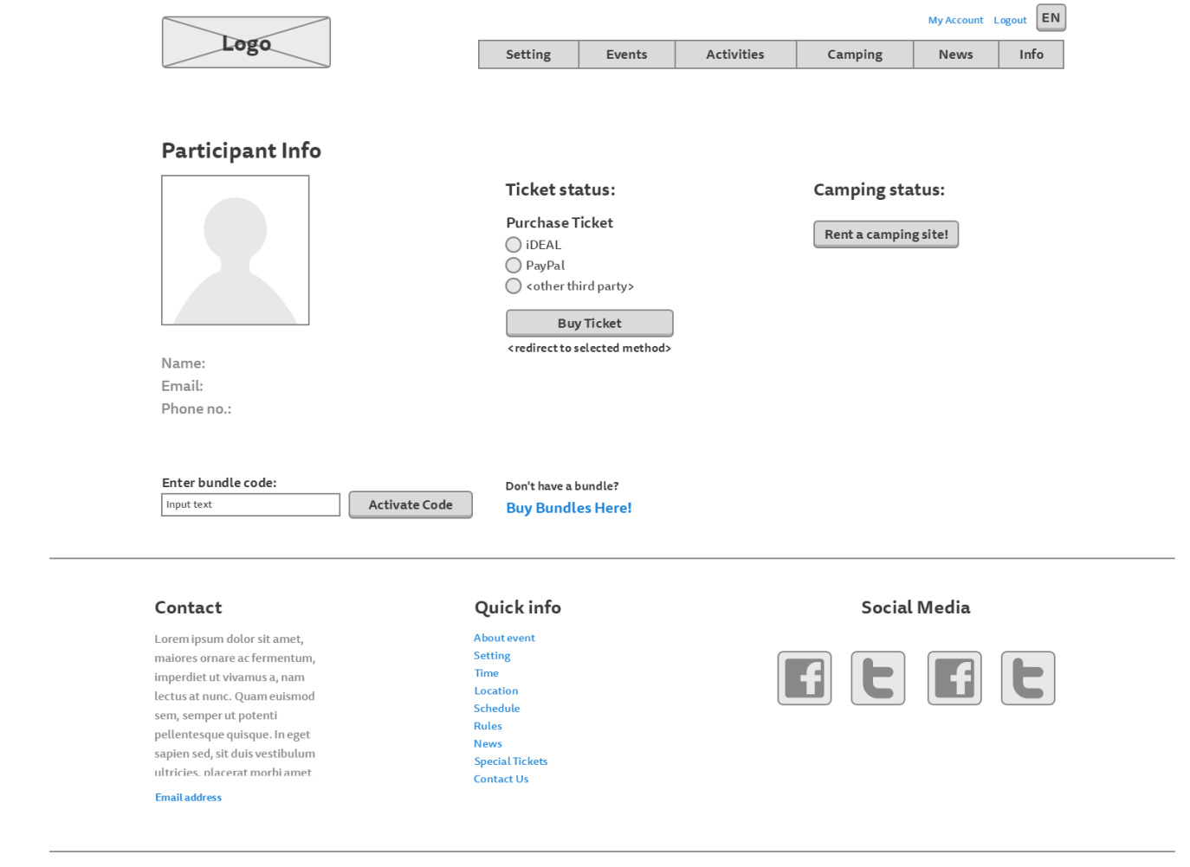

**Participant’s information page** (to show camping information)

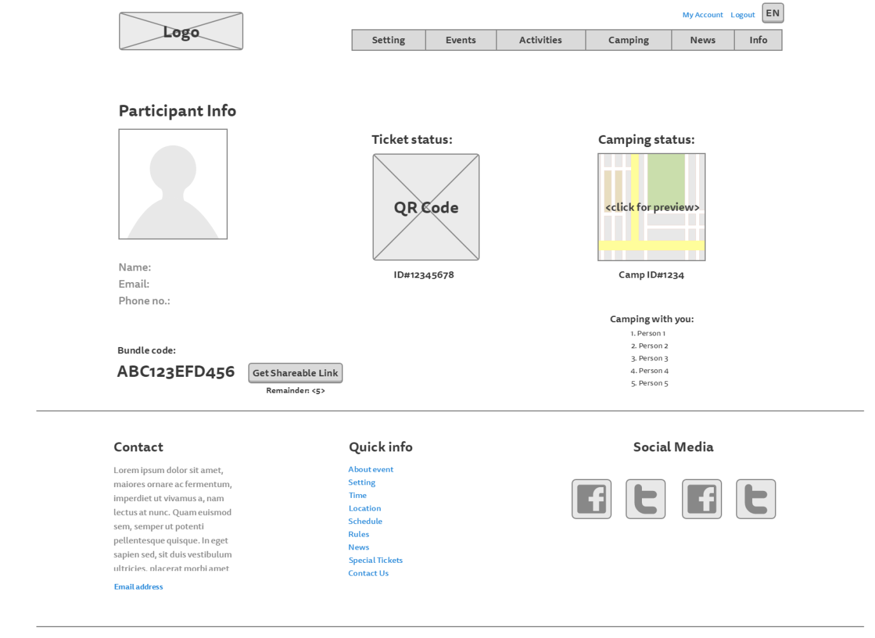

**Camping registration page:**

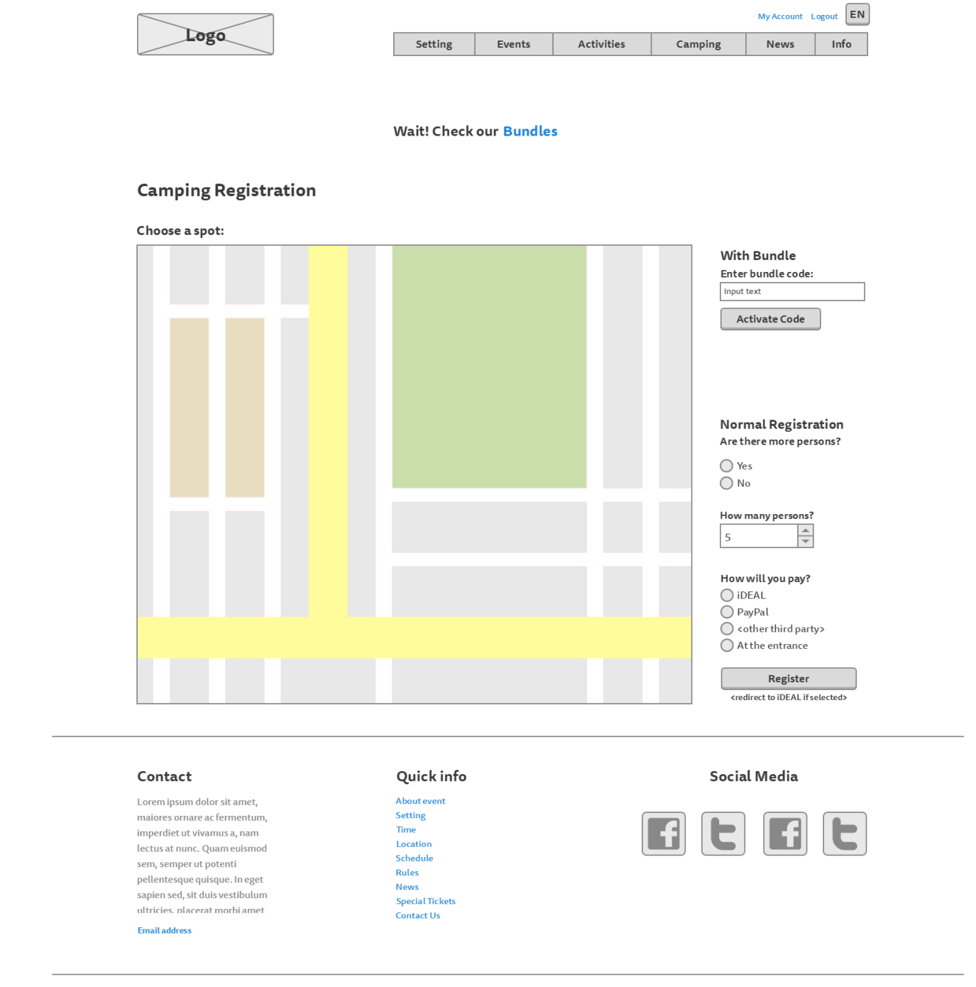

**Bundles page:**

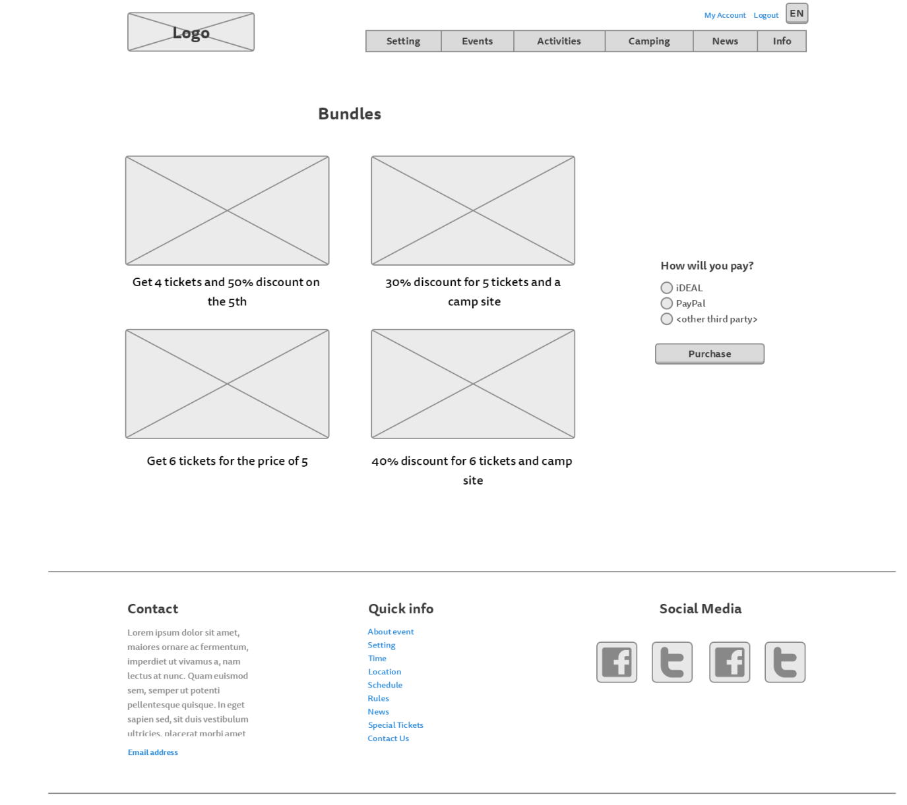

# Visual Design

**Homepage:**

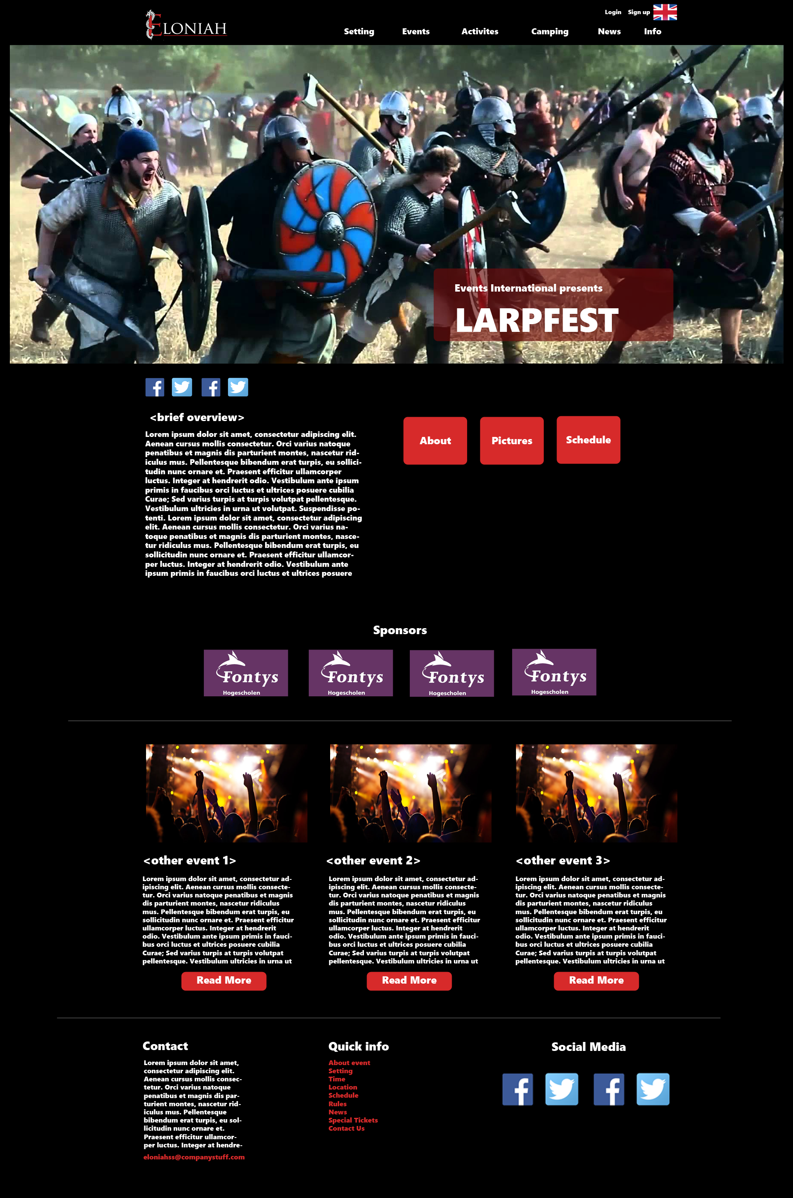

**Setting page:**

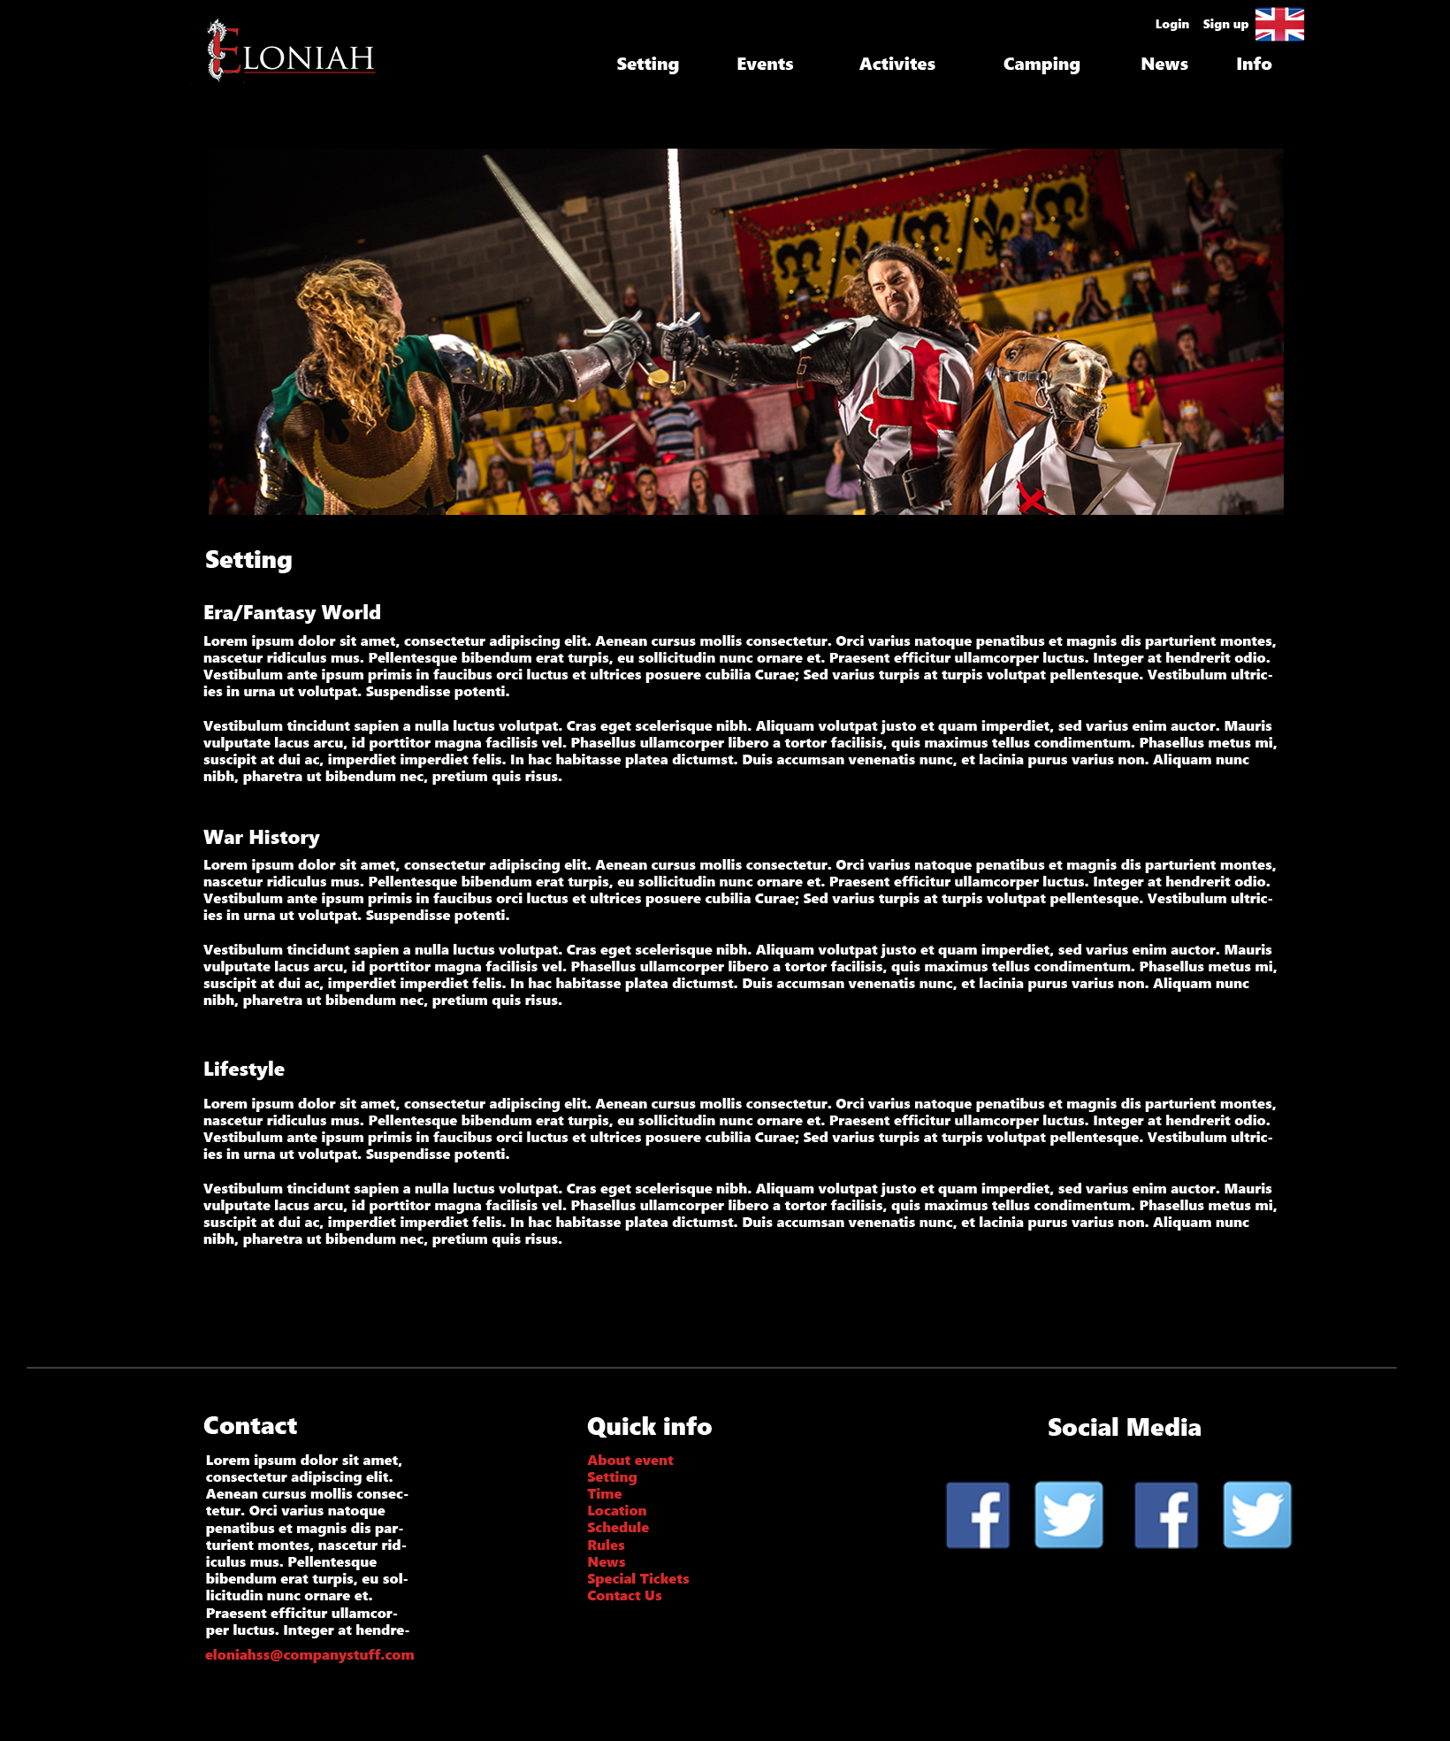

**Rules page:**

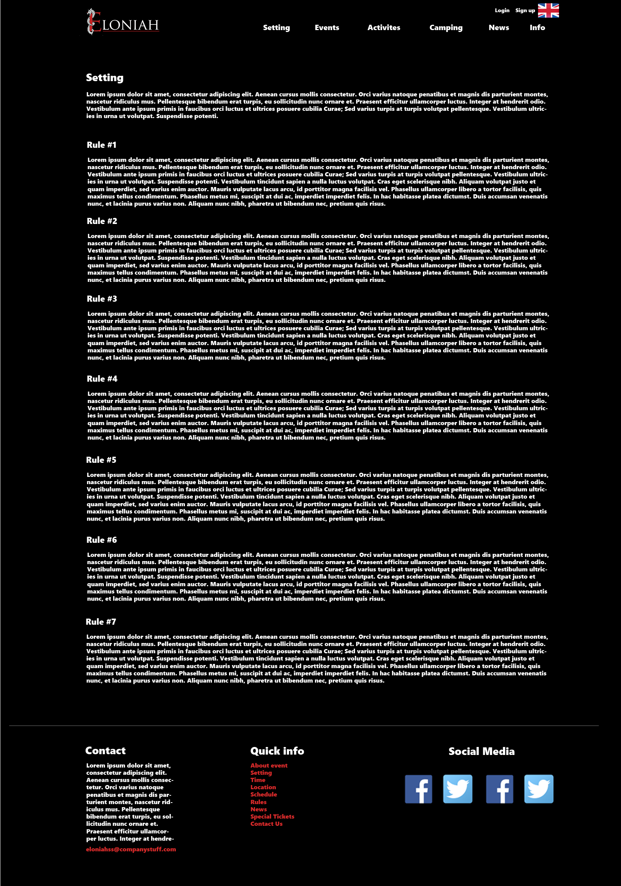

**Events page**

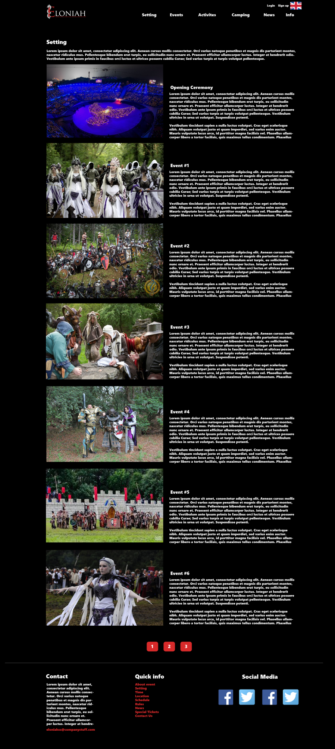

**Activities page:**

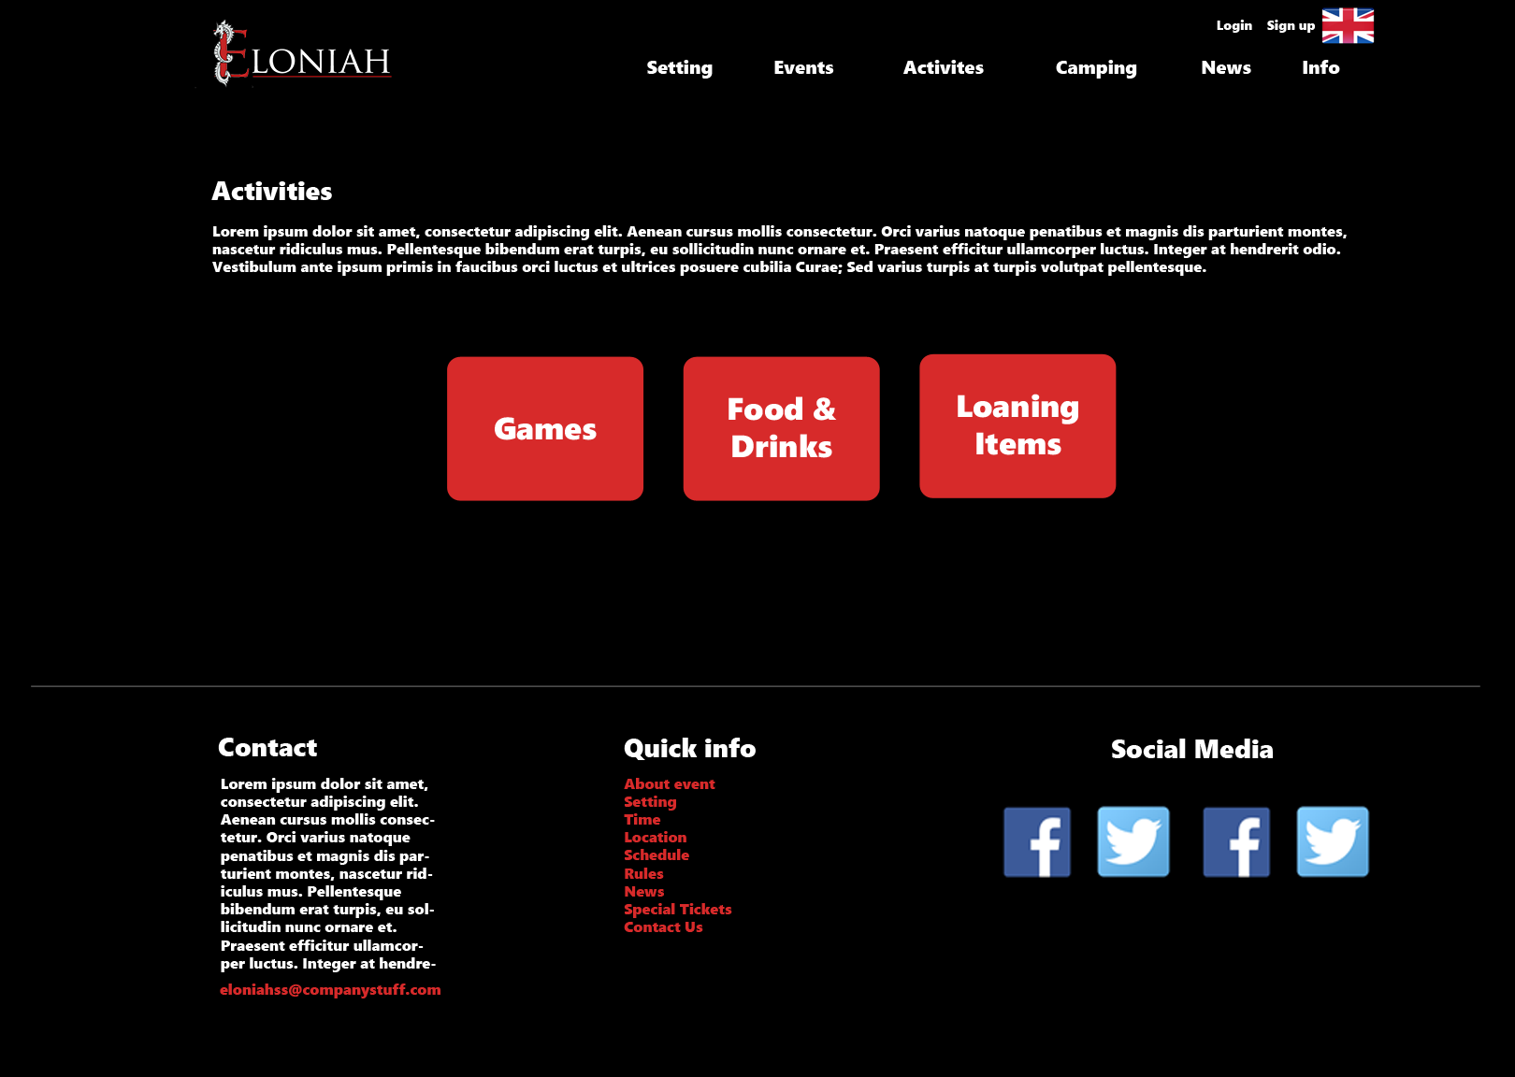

**Food, drinks and loaning items page**

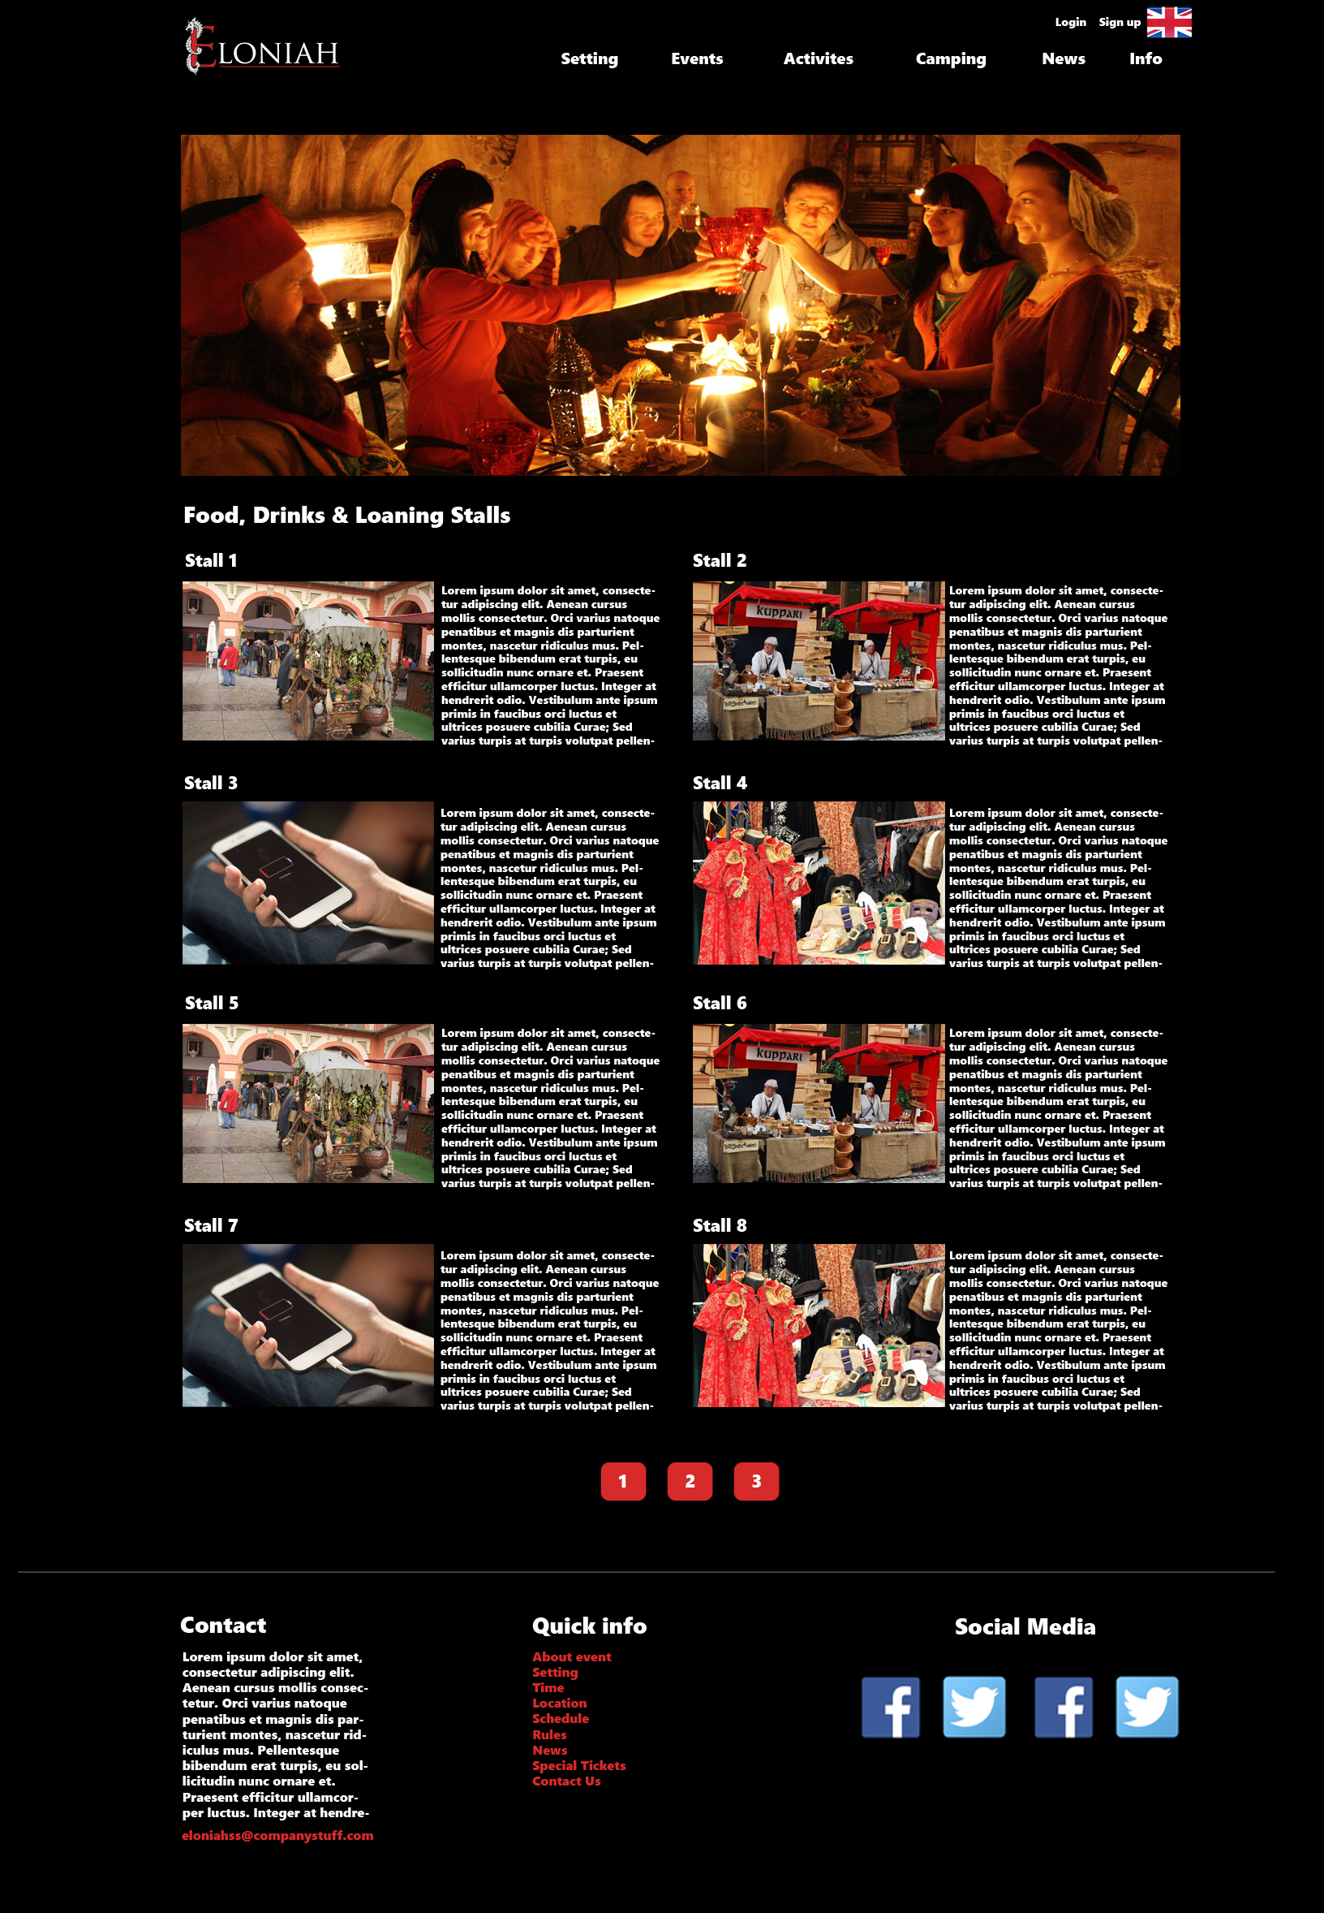

**Games page:**

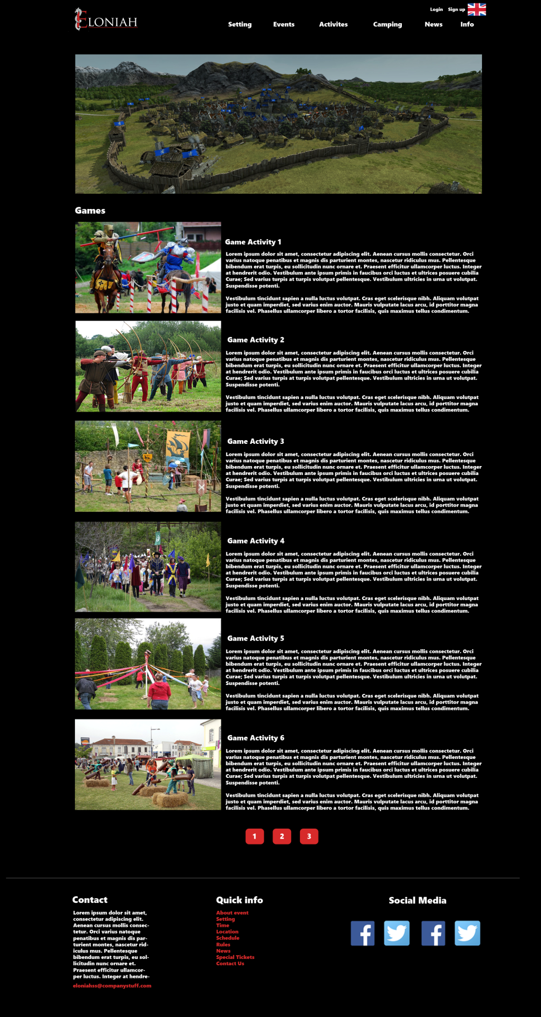

**Camping page:**

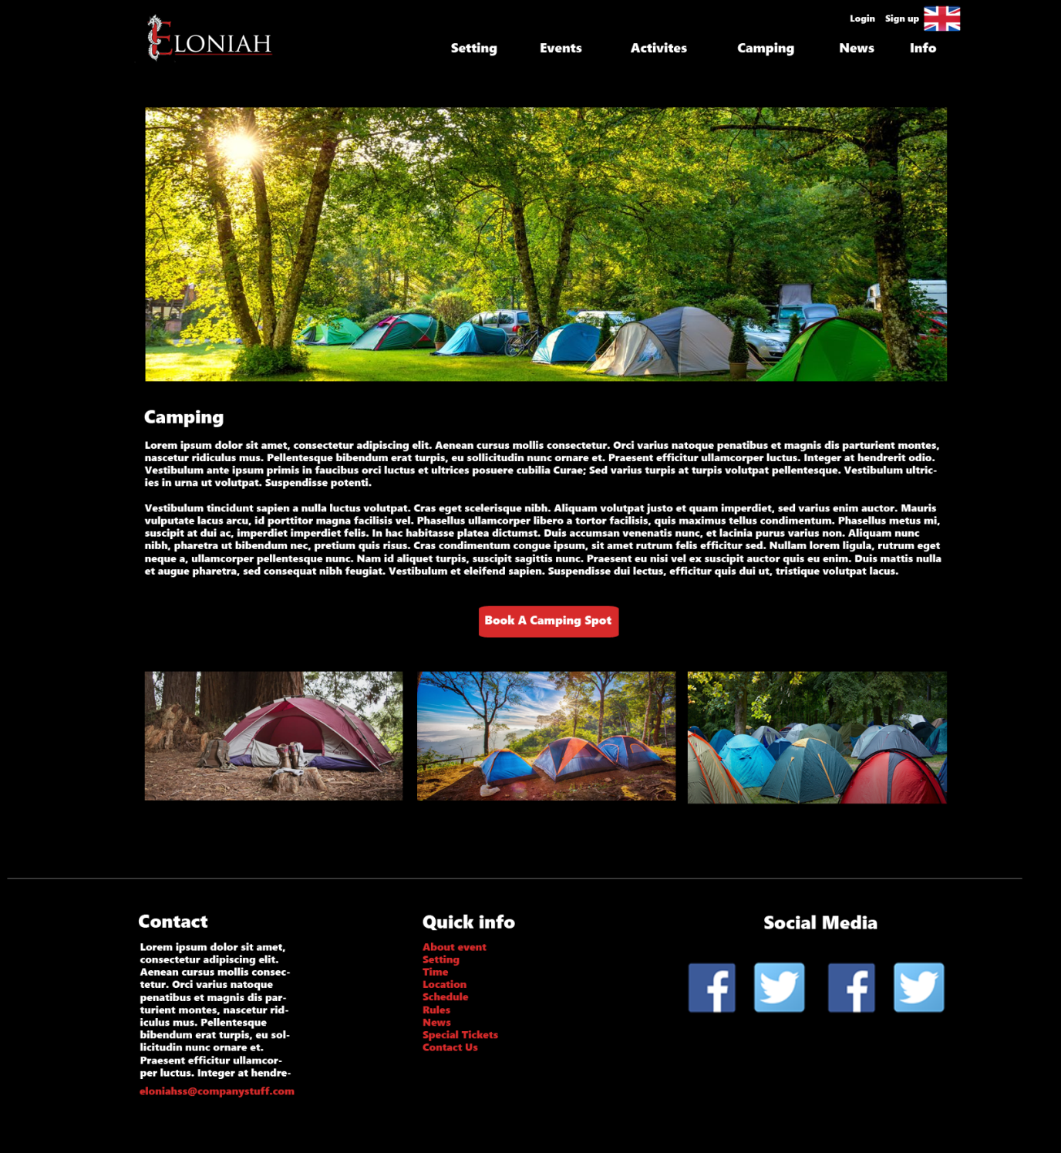

**News page:**

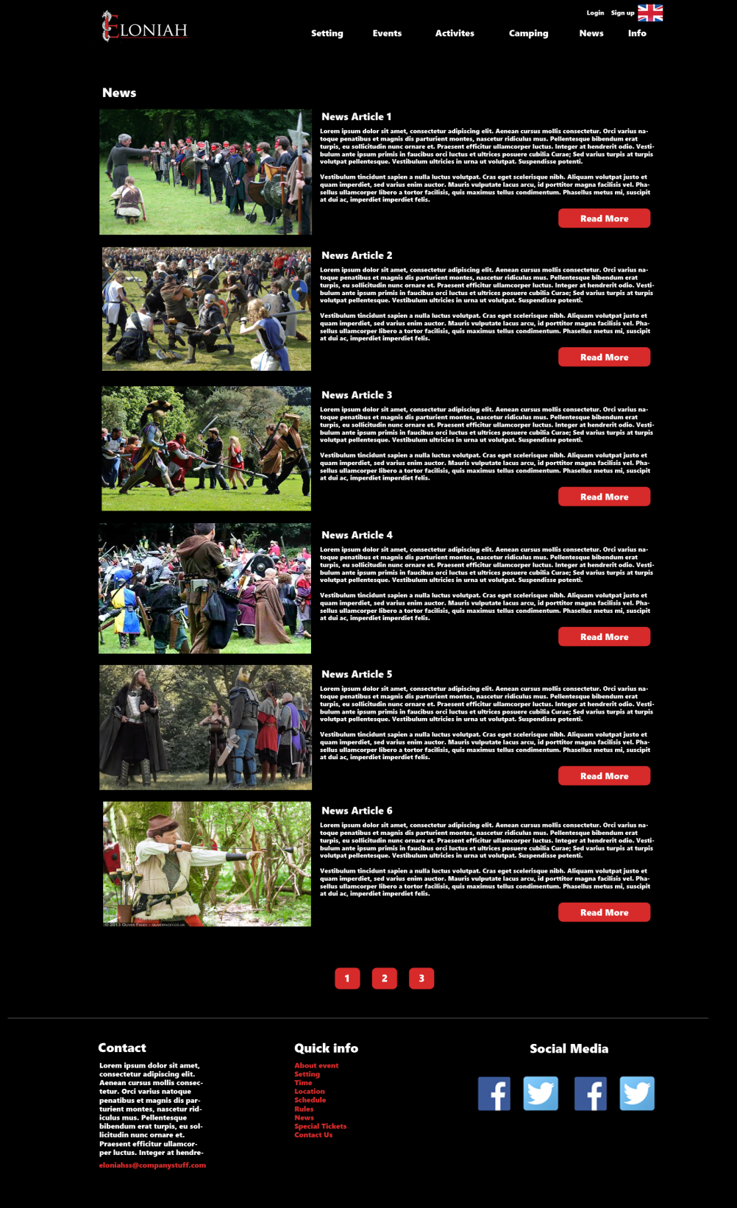

*News – read more:*

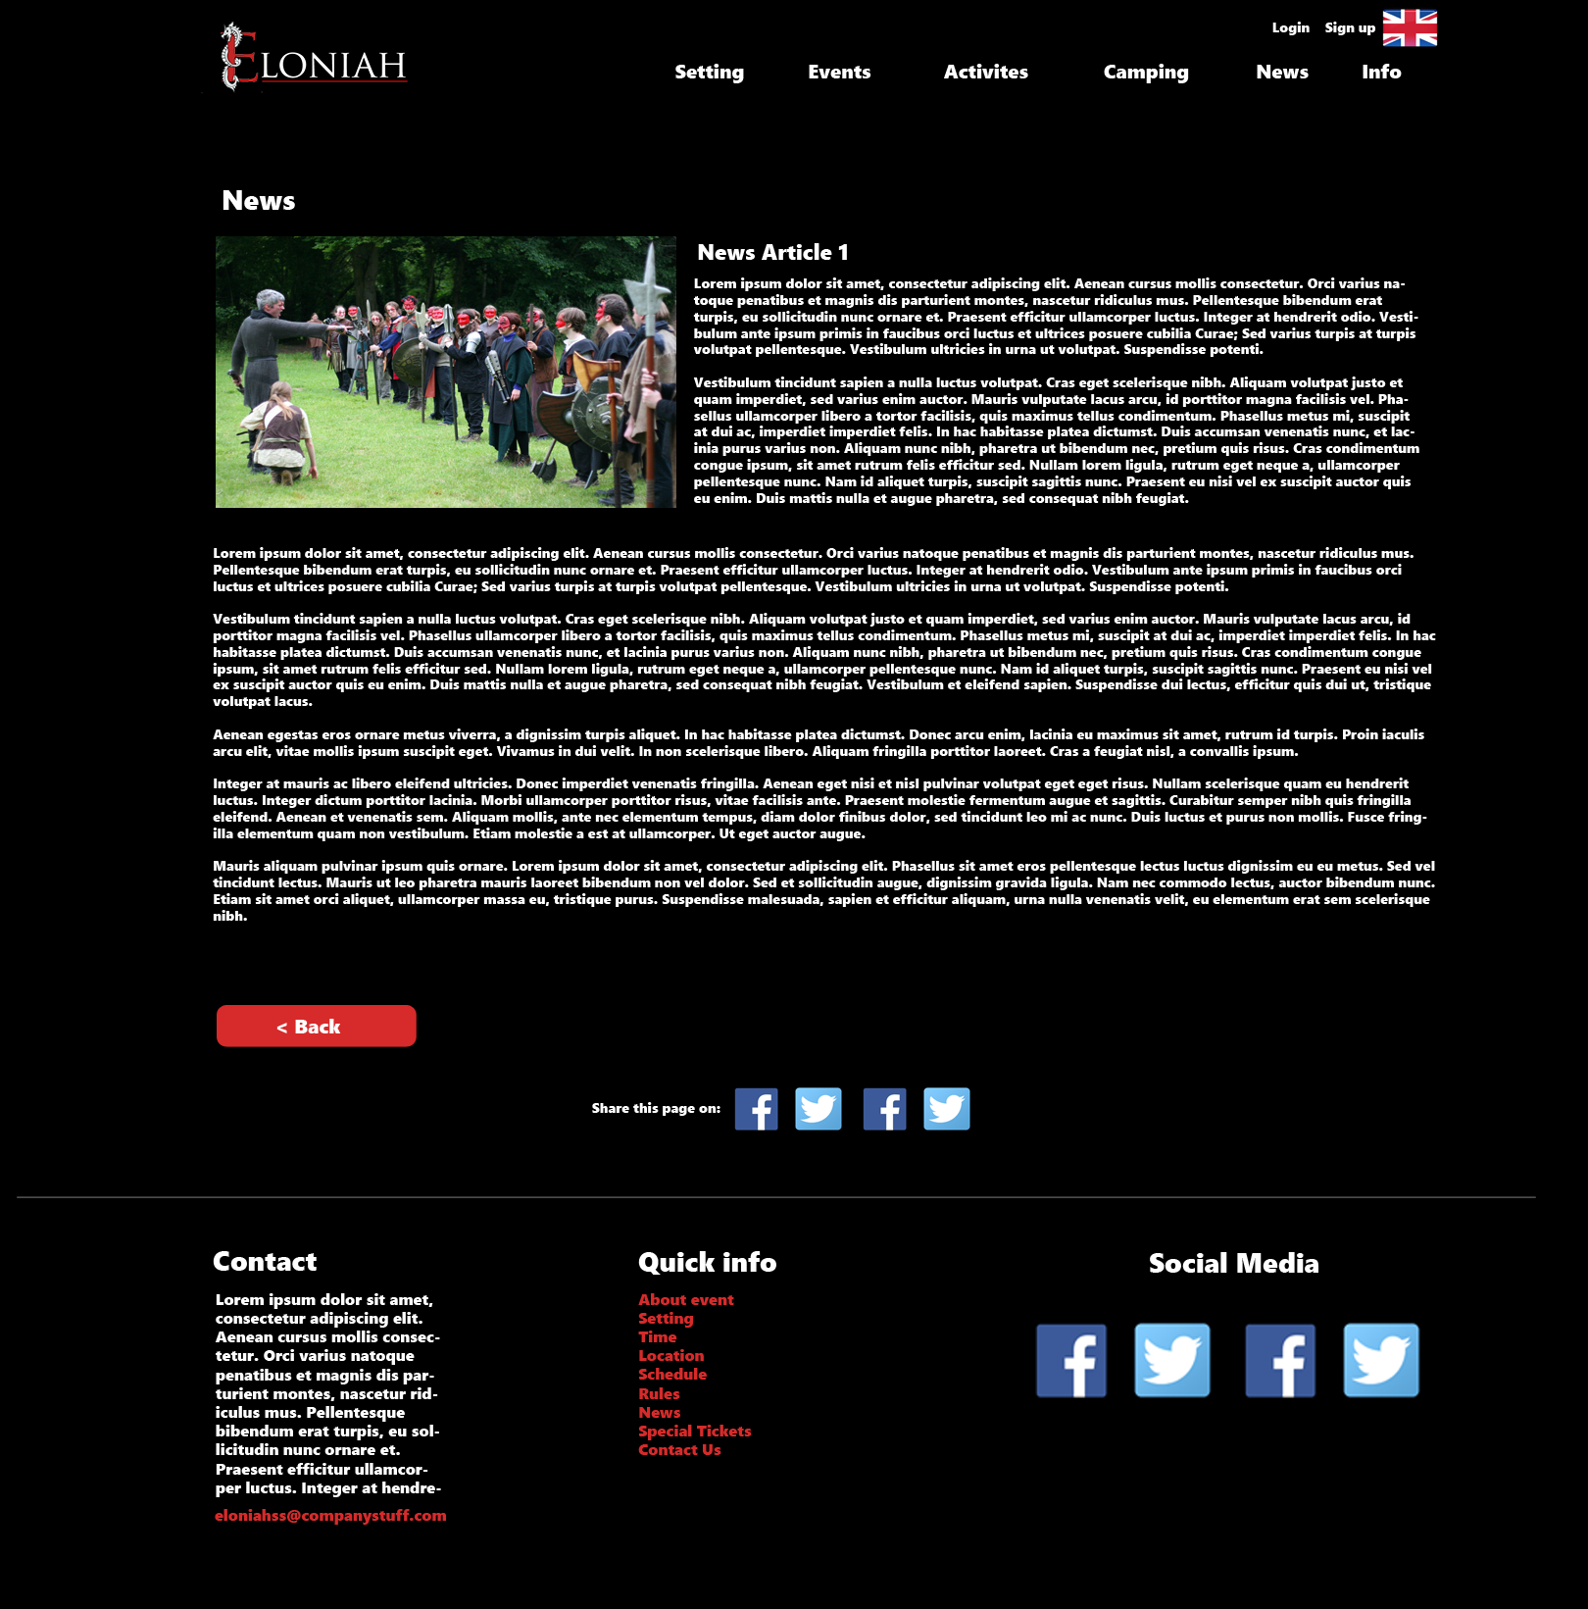

**About page:**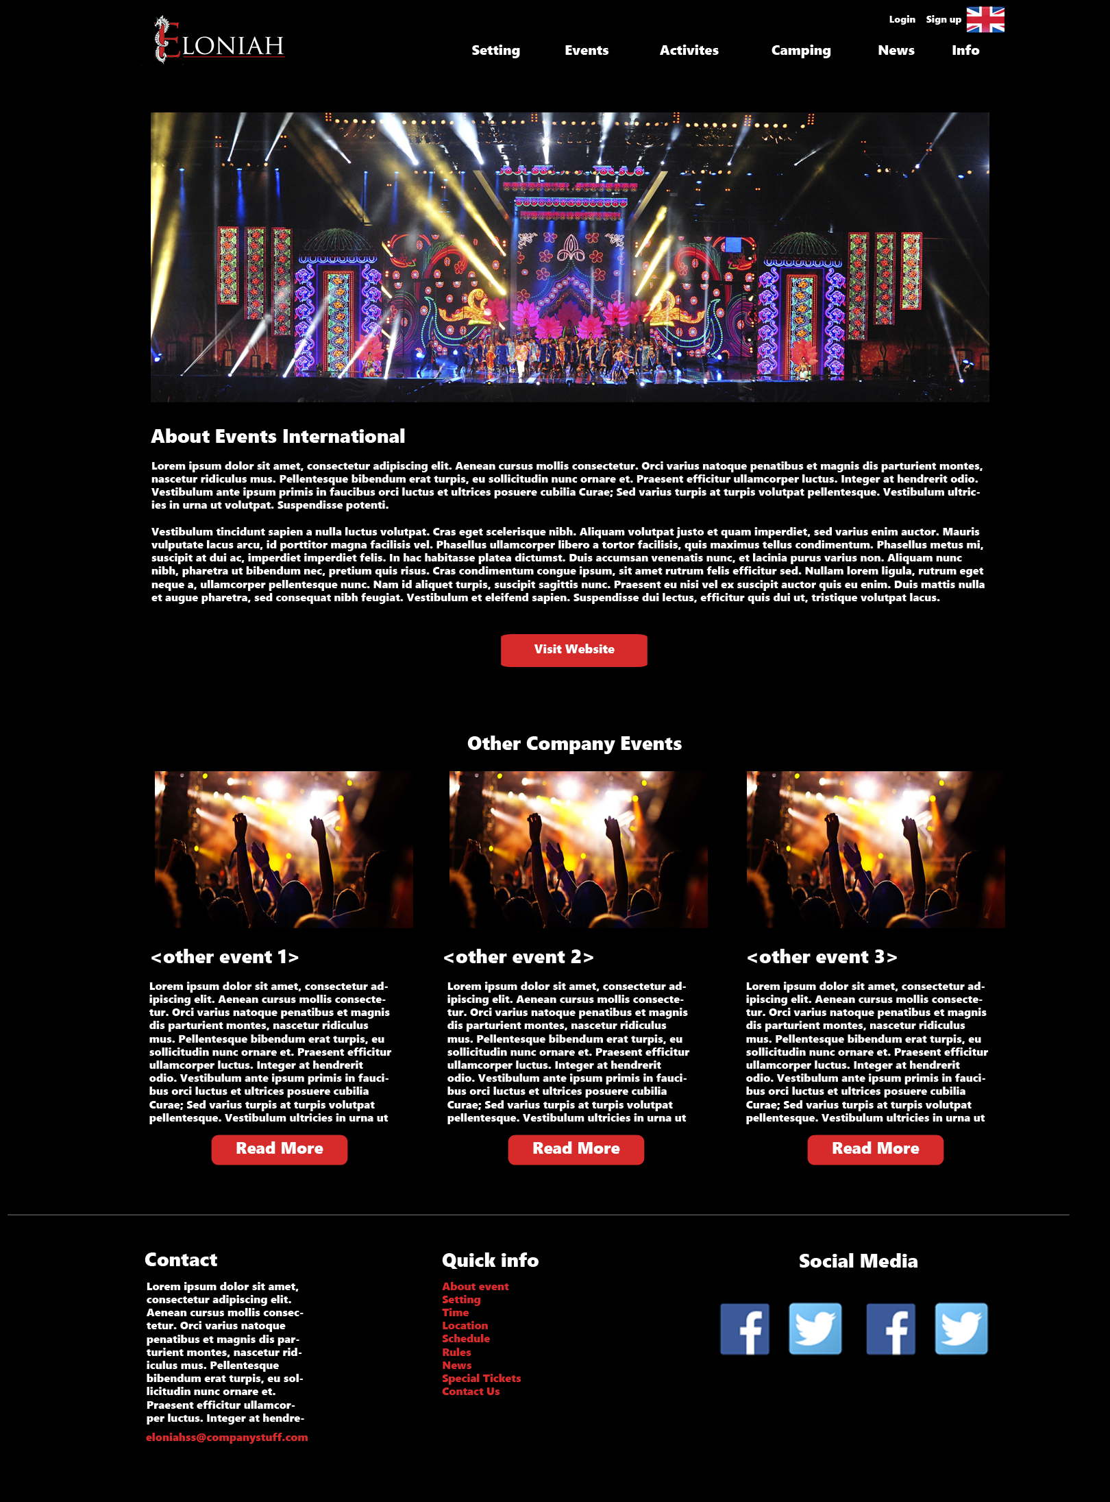

**Login page:**

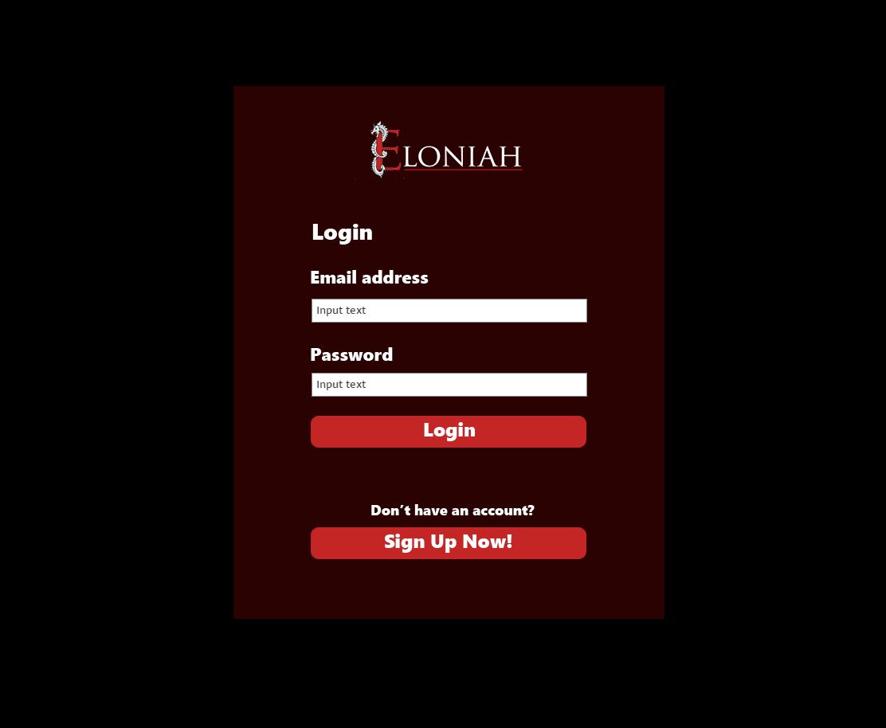

**Sign up page:**

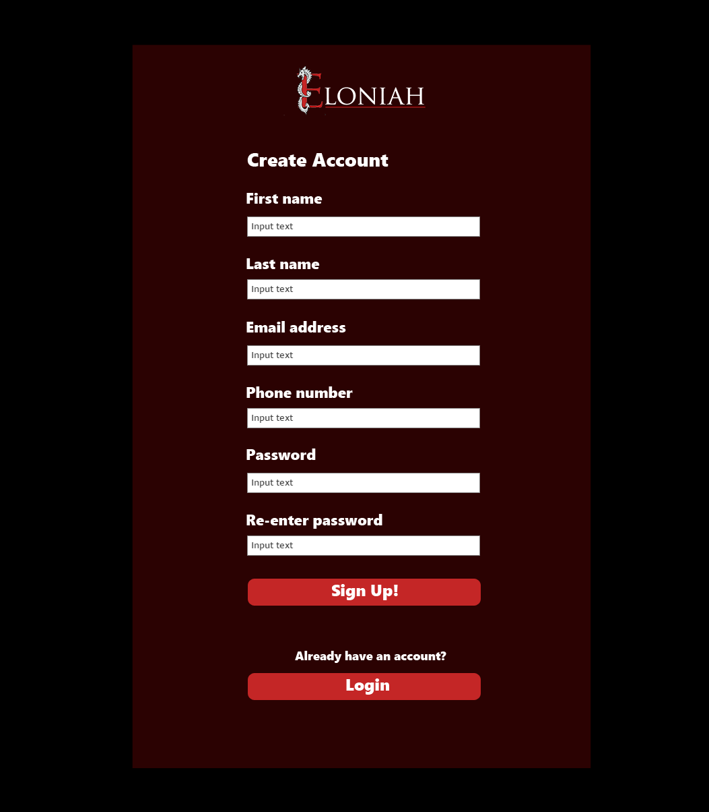

**Participant’s information page** (to show tickets information)

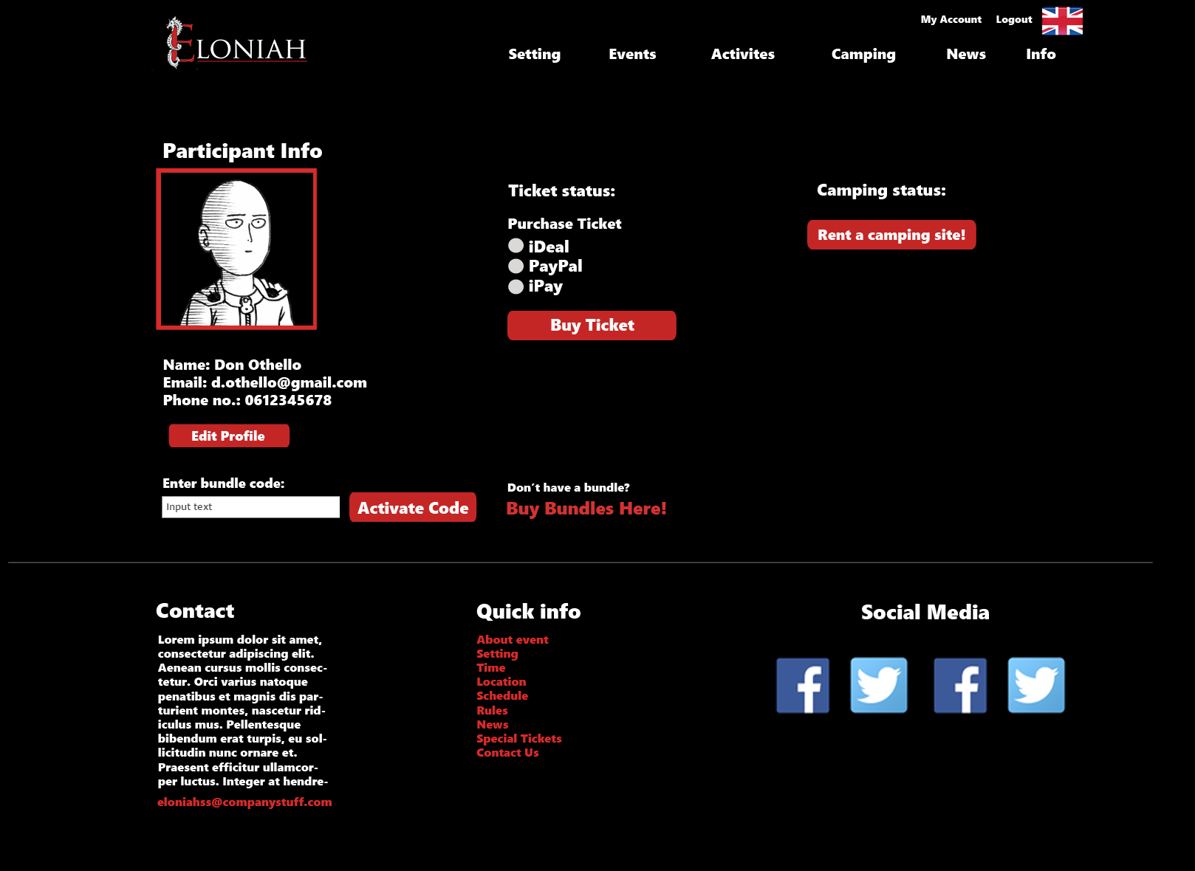

**Participant’s information page** (to show camping information)

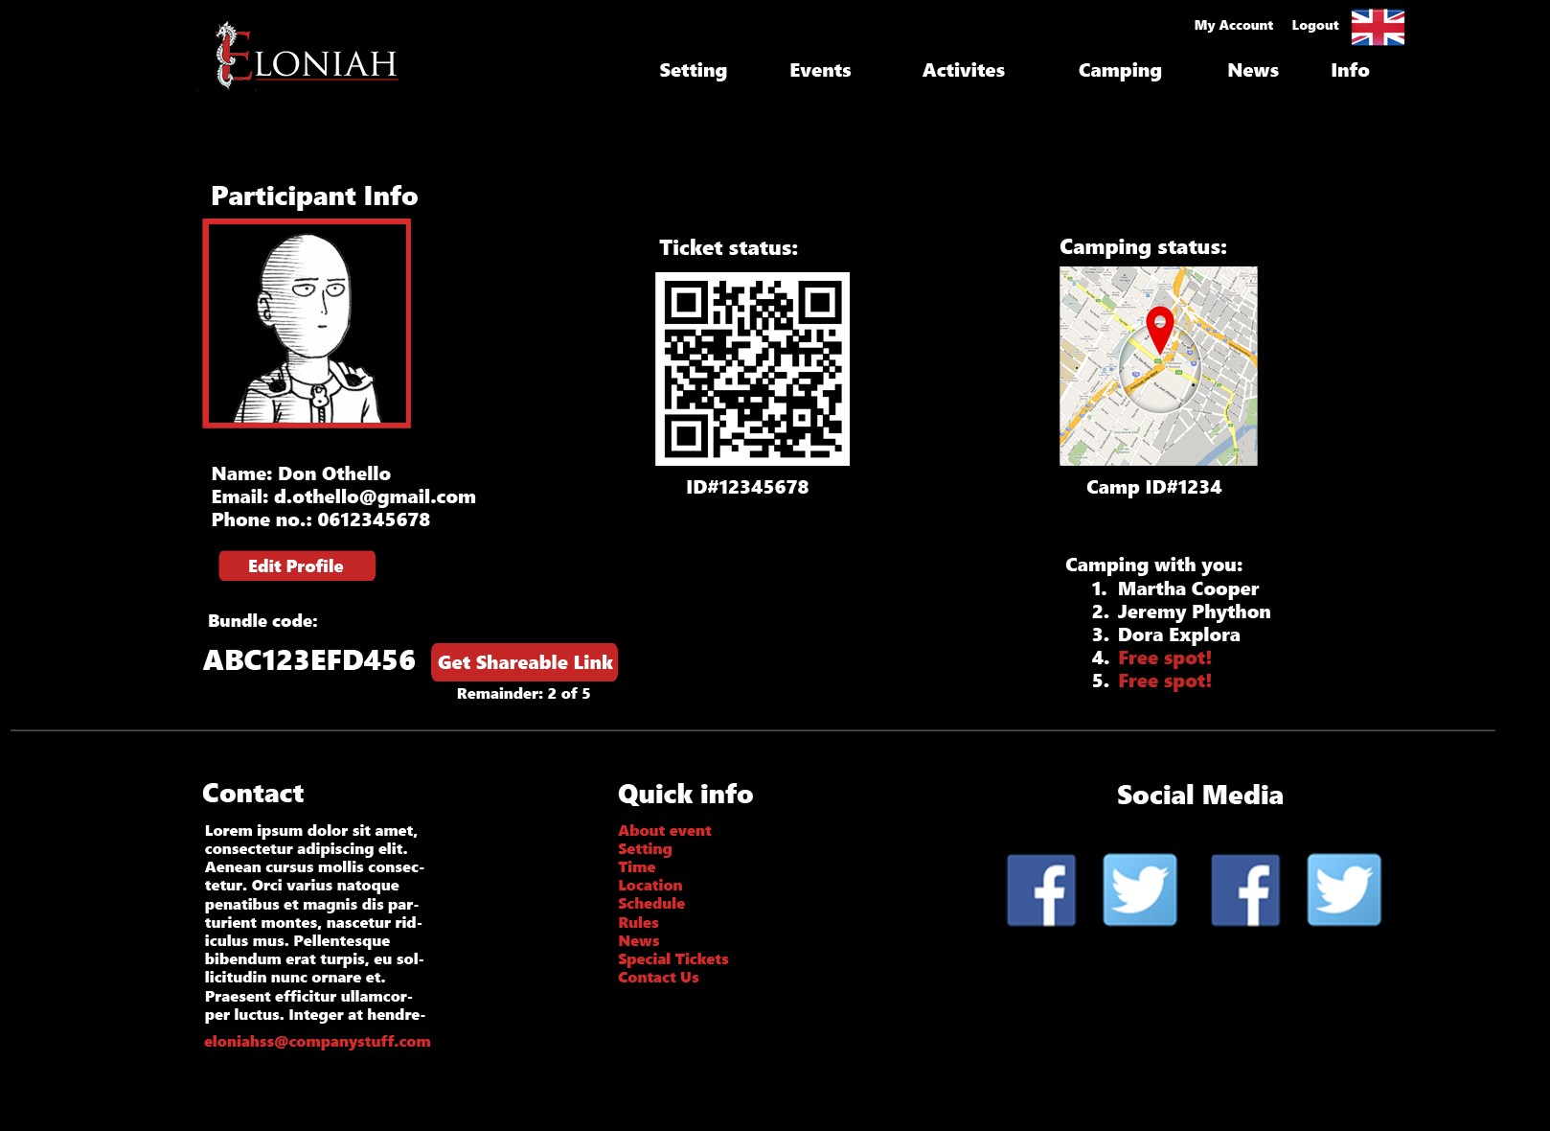

**Camping registration page:**

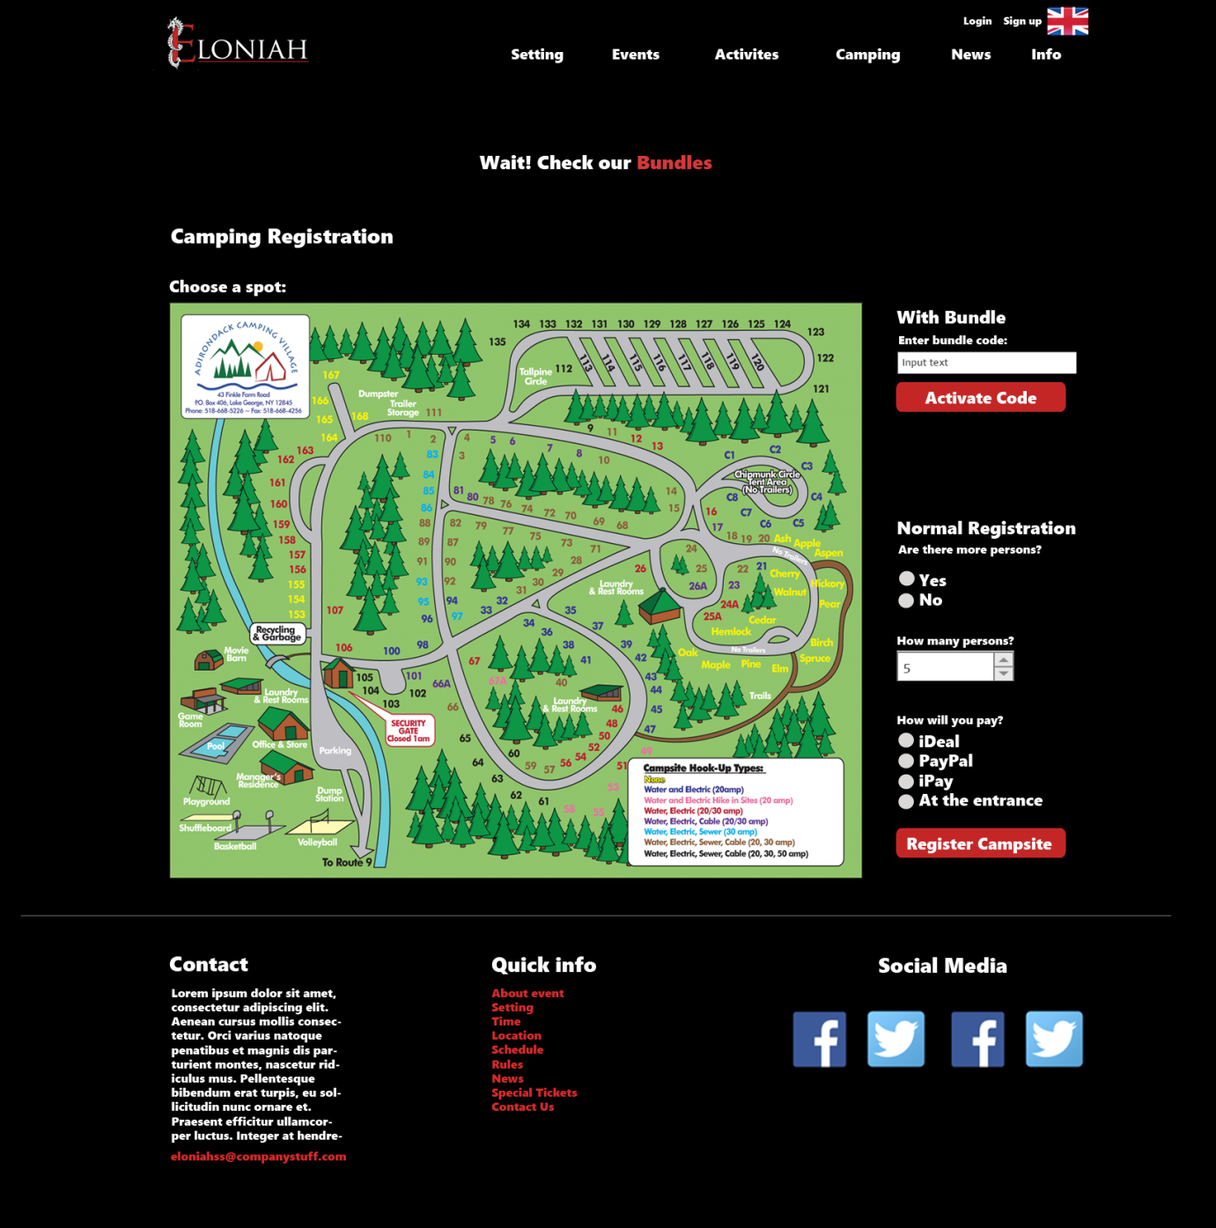

**Bundles page:**

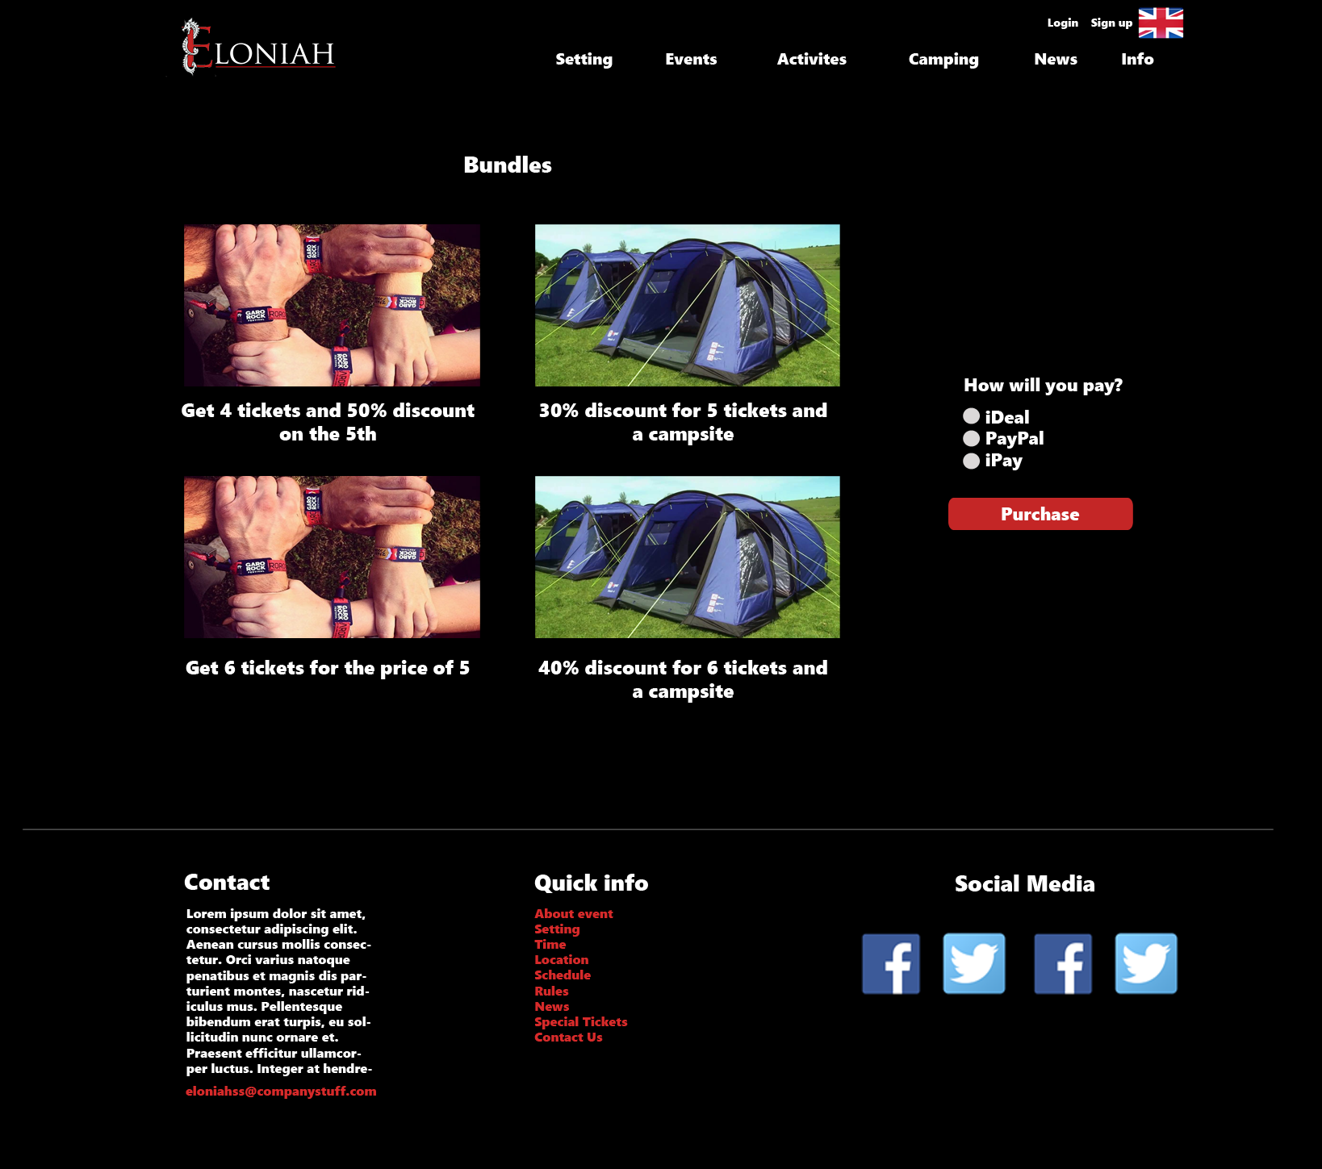

# ERD

* **Red**: The core entities.
* 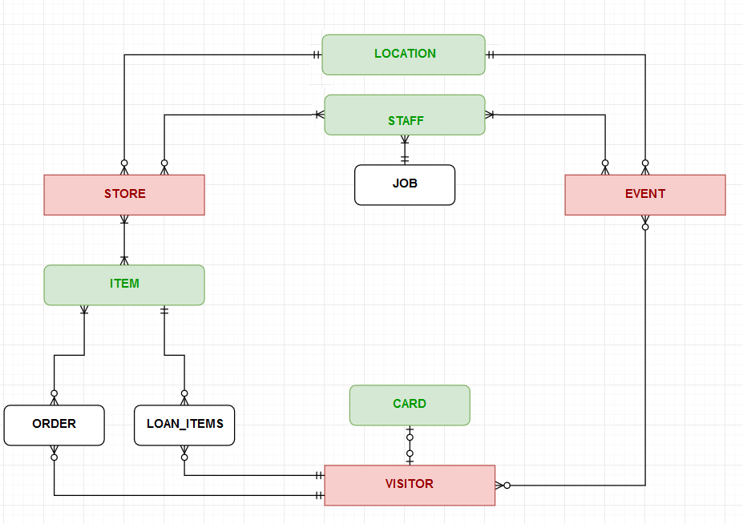**Green**: The entities supporting the core ones.
* **Black**: The entities supporting implementation.